Fannett-Metal School District - Elementary School November 2019

Fannett-Metal is an equal opportunity provider

SUNDAY | MONDAY | TUESDAY | WEDNESDAY | THURSDAY | FRIDAY | SATURDAY
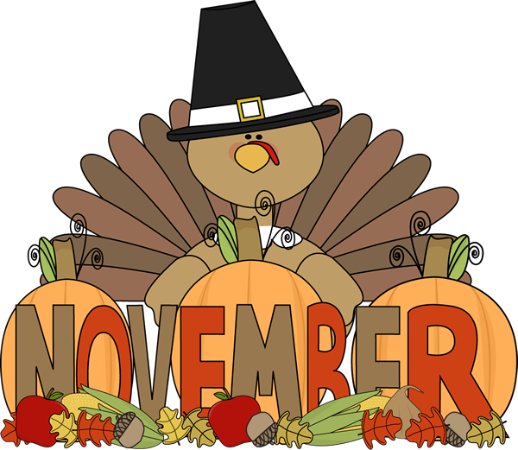 |  |  |  |  | November 1  Pizza  Or  Cheese Steak  Grape tomatoes  Corn  Choice of Fruit / Milk | Offer verses serve -  Students must take  3 of 5 items to count as a lunch & one must be a fruit or vegetable.
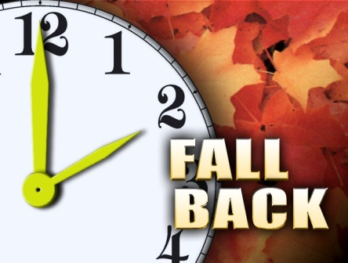 | November 4  Stuffed Shells  W / Roll  Or  Calzone  Baby Carrots  Tossed Salad  Choice of Fruit / Milk | November 5  Chicken Nuggets  W / Roll  Or  Cheeseburger  Steamed Carrots  Celery W / Dip  Choice of Fruit / Milk | November 6  Chicken Patty  Or  Soft Shell Taco  Refried Beans  Red Peppers  Choice of Fruit / Milk | November 7  Baked Spaghetti  Texas Toast  Or  Turkey & Cheese Hoagie  Steamed Broccoli  Tossed Salad  Choice of Fruit / Milk | November 8  French Bread Pizza  Or  Meatball Sub  Peas  Baby Carrots  Choice of Fruit / Milk
All Meals are  served with 1% milk, fat free chocolate, fat free vanilla, fat free strawberry and skim | November 11  No School | November 12  Walking Taco  Or  Hot Dog  Carrots W / Dip  Peas  Choice of Fruit / Milk | November 13  Chicken Alfredo  Roll  Or  Chef Salad W / Roll  Steamed Broccoli  Tossed Salad  Choice of Fruit / Milk  Choice of Fruit / Milk | November 14  Macaroni & Cheese  Or  Fish Nuggets  W / Roll  Grape Tomatoes  Steamed Carrots  Choice of Fruit / Milk | November 15  Pepperoni Pizza  Or  Shrimp Poppers / Roll  Baked Beans  Cucumbers W / Dip  Choice of Fruit / Milk | Pre-K Alternative:  November 12th – Popcorn Chicken W/ Goldfish Crackers
 | November 18  Tomato Soup  Grilled Cheese  Or  BBQ Rib Sandwich  Tossed Salad  Steamed Carrots  Choice of Fruit / Milk | November 19  Cheeseburger  Or  Chicken Fajita  Baked Beans  Baby Carrots  Choice of Fruit / Milk | November 20  Ravioli  Breadstick  Or  Turkey & Cheese Wrap  Broccoli  Grape Tomatoes  Choice of Fruit / Milk | November 21  Roast Turkey, Gravy & Stuffing or Roll  Or  Calzone  Mashed Potatoes  Corn  Choice of Fruit / Milk | November 22  French Bread Pizza  Or  Fish Nuggets  W/ Roll  Peas  Celery W/ Dip  Choice of Fruit / Milk | Elementary Lunch-  $ 2.65  Milk - .50  Reduced - .40
No breakfast on two hour delays | November 25  Macaroni & Beef Pasta  Breadstick  Or  Grilled Chicken Sandwich  Peas  Celery W / Dip  Choice of Fruit / Milk | November 26  Chicken & Waffles  W/ Gravy  Or  Hamburger  Tossed Salad  Grape Tomatoes  Choice of Fruit / Milk | November 27  Shrimp Poppers  W / Roll  Or  Chef Salad w/ Roll  Steamed Broccoli  Choice of Vegetable  Choice of Fruit / Milk | November 28  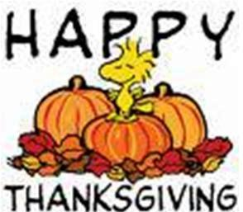 | November 29  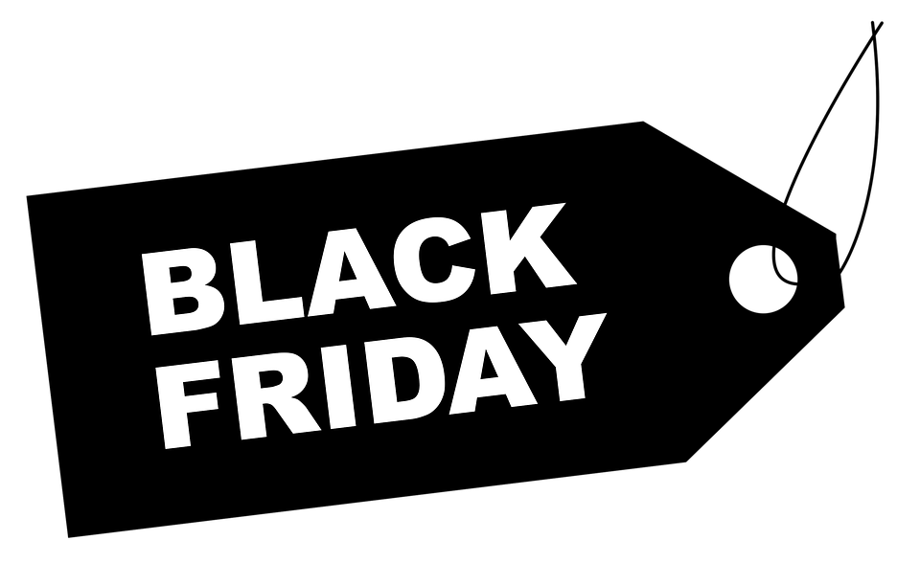 | Menu subject to change

