Fannett-Metal School District - High School / Middle School October 2019

Fannett-Metal is an equal opportunity provider

SUNDAY | MONDAY | TUESDAY | WEDNESDAY | THURSDAY | FRIDAY | SATURDAY
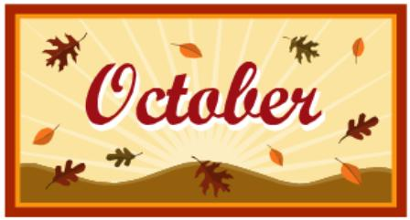 |  | October 1  Walking Taco  Or  Fish Nuggets  W/G Roll  Refried Beans  Baby Carrots  Choice of Fruit / Milk | October 2  Cheesesteak  Or  Spicy Chicken Sandwich  Baked Beans  Celery  Choice of Fruit / Milk | October 3  Hot Turkey Sandwich  w/ gravy  Or  Hot Dog  French Fries  Baby Carrots  Choice of Fruit / Milk | October 4  Pepperoni Pizza  Or  Fish Sandwich  Broccoli w/ Cheese  Grape Tomatoes  Choice of Fruit / Milk | Offer verses serve -  Students must take  3 of 5 items to count as a lunch & one must be a fruit or vegetable.
 | October 7  Cheeseburger Sub  W/G Roll  Or  BBQ Rib Sandwich  Broccoli w/ Cheese  French Fries  Choice of Fruit / Milk | October 8  Cheeseburger Sliders  Or  Rotisserie Chicken Wrap  Peas  Red Peppers W / Dip  Choice of Fruit / Milk | October 9  Pizza  Or  Cheeseburger  W/G Roll  Grape Tomatoes  Baked Beans  Choice of Fruit / Milk | October 10  General Tso’s Chicken  w/ W/G roll  Or  Grilled Ham & Cheese  Oriental Vegs/ Rice  Baby Carrots  Choice of Fruit / Milk | October 11  Pulled Pork Sandwich  Or  Turkey & Cheese Flatbread  Green Beans  Tossed Salad  Choice of Fruit / Milk | Daily Entrée options include:  Chef Or Taco Salad with whole grain roll Or Whole grain P B & J sandwich  Fruit, Vegetable & milk are included
All Meals are  served with 1% milk, fat free chocolate, fat free vanilla, fat free strawberry and skim | October 14  No School | October 15  Chicken & Waffles  W / Gravy  Or  Calzone  Baked Beans  Grape Tomatoes  Choice of Fruit / Milk | October 16  Shrimp Poppers  W / Roll  Or  Chicken Cheesesteak  French Fries  Baby Carrots  Choice of Fruit / Milk | October 17  Stuffed Shells  Breadstick  Or  Cheeseburger  Broccoli  Tossed Salad  Choice of Fruit / Milk | October 18  Pepperoni Pizza  Or  Meatball Sub  Peas  Baby Carrots  Choice of Fruit / Milk
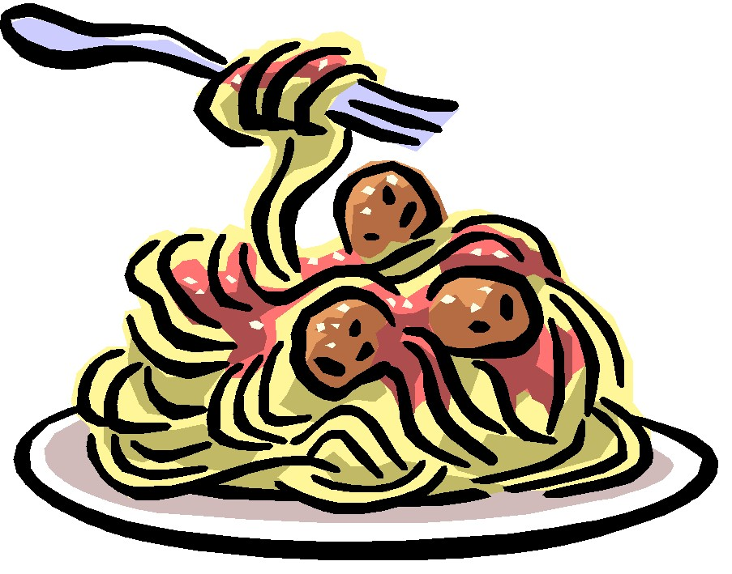 | October 21  Baked Spaghetti  Texas Toast  Or  Ham & Cheese Pretzel Roll  Tossed Salad  Peas  Choice of Fruit / Milk | October 22  Nacho Grande  Or  Turkey Club Wrap  Cheesy Broccoli  Cucumber W / Dip  Choice of Fruit / Milk | October 23  Chicken Alfredo  W / Roll  Or  BBQ Rib Sandwich  Baby Carrots  Refried Beans  Choice of Fruit / Milk | October 24  Macaroni & Cheese  Or  Calzone  Grape Tomatoes  Green Beans  Choice of Fruit / Milk | October 25  No School | Middle/HS Lunch-  $ 2.80  Milk - .50  Reduced - .40
No breakfast on two hour delays | October 28  Tomato Soup  Grilled Cheese  Or  Chicken Fajita  Peas  Tossed Salad  Choice of Milk / Fruit | October 29  Walking Taco  Or  Fish Nuggets  W / Roll  Refried Beans  Baby Carrots  Choice of Fruit / Milk | October 30  Cheese Steak  Or  Spicy Chicken Sandwich  Corn  Celery  Choice of Fruit / Milk | October 31  Hot Turkey Sandwich  w/ gravy  Or  Hot Dog  Mashed Potato  Baby Carrots  Choice of Fruit / Milk | November 1  Pepperoni Pizza  Or  Rotisserie Chicken Wrap  Broccoli w/ Cheese  Grape Tomatoes  Choice of Fruit / Milk | Menu subject to change

