FANNETT-METAL SCHOOL DISTRICT – Elementary School –
October 2019
Breakfast Menu

Fannett-Metal School District is an equal opportunity provider
SUNDAY | MONDAY | TUESDAY | WEDNESDAY | THURSDAY | FRIDAY | SATURDAY
 |  | October 1  Scrambled Eggs  Or  Cereal  Whole Grain Bread  Fruit / Vegetable  Milk / Juice | October 2  Waffle & Sausage Patty  Or  Cereal  Whole Grain Bread  Fruit / Vegetable  Milk / Juice | October 3  Breakfast Pizza  Or  Cereal  Whole grain bread  Fruit / Vegetable  Milk / Juice | ^{October 4}  Mini Pancakes  Or  Cereal  Whole grain Bread  Fruit / Vegetable  Milk / Juice
 | October 7  French Toast Sticks  Or  Cereal  Whole grain bread  Fruit / Vegetable  Milk / Juice | October 8  Scrambled Eggs  Or  Cereal  Whole Grain Bread  Fruit / Vegetable  Milk / Juice | October 9  Waffle & Sausage Patty  Or  Cereal  Whole Grain Bread  Fruit / Vegetable  Milk / Juice | October 10  Breakfast Pizza  Or  Cereal  Whole grain bread  Fruit / Vegetable  Milk / Juice | October 11  Mini Pancakes  Or  Cereal  Whole grain Bread  Fruit / Vegetable  Milk / Juice
All Meals are  served with 1% milk, fat free chocolate, fat free vanilla, fat free strawberry and skim | October 14  No School | October 15  Scrambled Eggs  Or  Cereal  Whole Grain Bread  Fruit / Vegetable  Milk / Juice | October 16  Waffle & Sausage Patty  Or  Cereal  Whole Grain Bread  Fruit / Vegetable  Milk / Juice | October 17  Breakfast Pizza  Or  Cereal  Whole grain bread  Fruit / Vegetable  Milk / Juice | October 18  Mini Pancakes  Or  Cereal  Whole grain Bread  Fruit / Vegetable  Milk / Juice
 | October 21  French Toast Sticks  Or  Cereal  Whole grain bread  Fruit / Vegetable  Milk / Juice | October 22  Scrambled Eggs  Or  Cereal  Whole Grain Bread  Fruit / Vegetable  Milk / Juice | October 23  Waffle & Sausage Patty  Or  Cereal  Whole Grain Bread  Fruit / Vegetable  Milk / Juice | October 24  Breakfast Pizza  Or  Cereal  Whole grain bread  Fruit / Vegetable  Milk / Juice | ^{October 25}  ^{No School} | Elementary & MS/HS  Breakfast-$ 1.55  Milk -$.50  Reduced -$.25
 | October 28  French Toast Sticks  Or  Cereal  Whole grain bread  Fruit / Vegetable  Milk / Juice | October 29  Scrambled Eggs  Or  Cereal  Whole Grain Bread  Fruit / Vegetable  Milk / Juice | October 30  Waffle & Sausage Patty  Or  Cereal  Whole Grain Bread  Fruit / Vegetable  Milk / Juice | October 31  Breakfast Pizza  Or  Cereal  Whole grain bread  Fruit / Vegetable  Milk / Juice | ^{November 1}  Mini Pancakes  Or  Cereal  Whole grain Bread  Fruit / Vegetable  Milk / Juice | 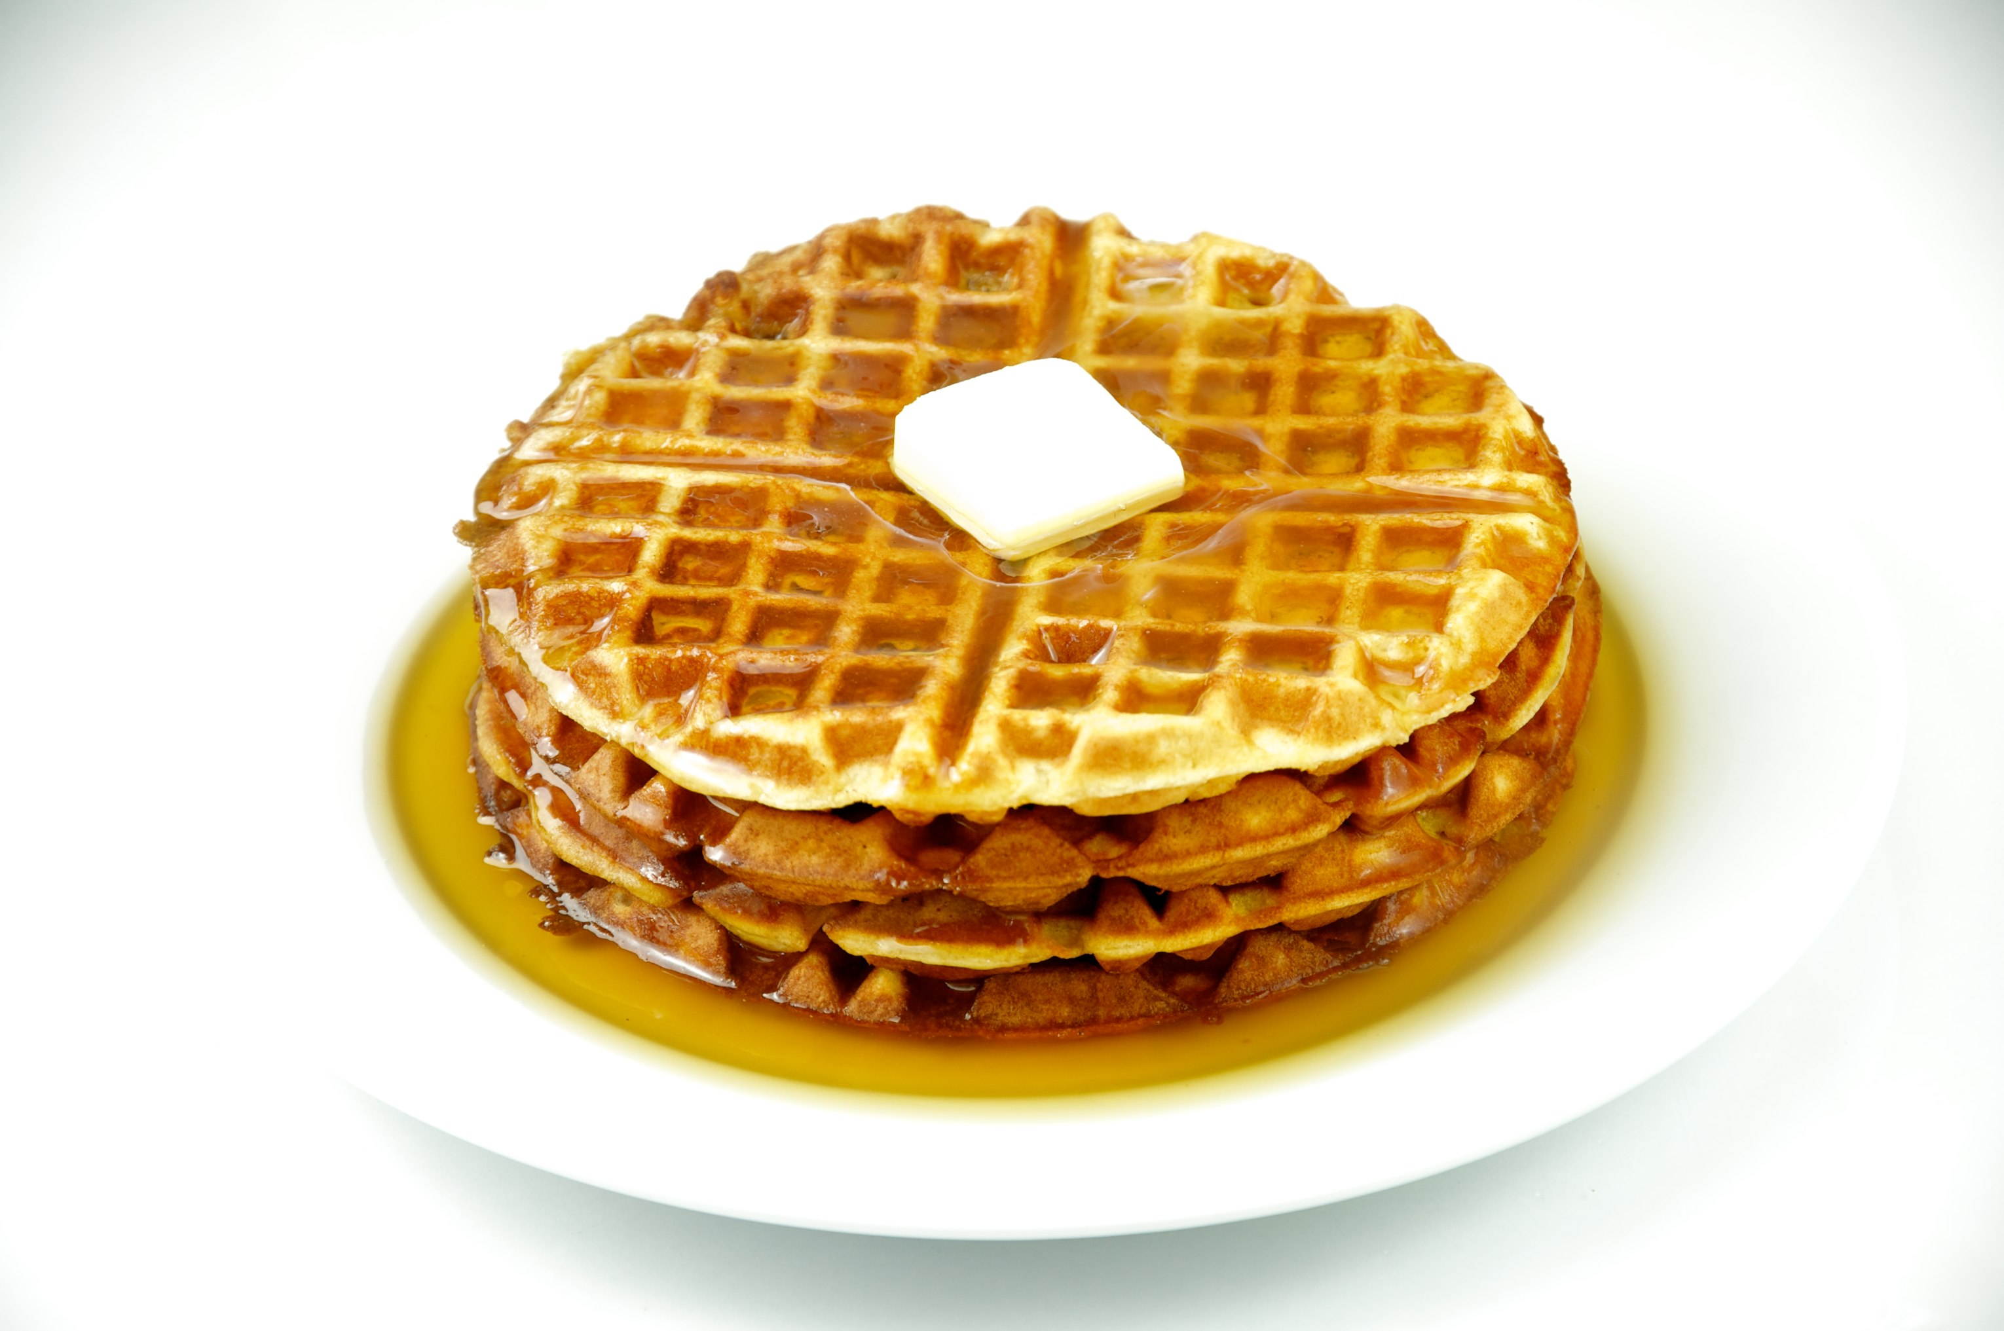
To manage accounts: www.myschoolaccount.com No breakfast on 2 hour delays *Menu Subject to Change

