FANNETT-METAL SCHOOL DISTRICT – Elementary School –
September 2019
Breakfast Menu

Fannett-Metal School District is an equal opportunity provider
SUNDAY | MONDAY | TUESDAY | WEDNESDAY | THURSDAY | FRIDAY | SATURDAY
 |  | September 3  Pancakes on a stick  Or  Cereal  Whole Grain Bread  Fruit / Vegetable  Milk / Juice | September 4  Waffle & Sausage Patty  Or  Cereal  Whole Grain Bread  Fruit / Vegetable  Milk / Juice | September 5  Breakfast Pizza  Or  Cereal  Whole grain bread  Fruit / Vegetable  Milk / Juice | ^{September 6}  Mini Pancakes  Or  Cereal  Whole grain Bread  Fruit / Vegetable  Milk / Juice
 | September 9 French  No School | September 10  No School | September 1  Waffle & Sausage Patty  Or  Cereal  Whole Grain Bread  Fruit / Vegetable  Milk / Juice | September 12  Breakfast Pizza  Or  Cereal  Whole grain bread  Fruit / Vegetable  Milk / Juice | September 13  Mini Pancakes  Or  Cereal  Whole grain Bread  Fruit / Vegetable  Milk / Juice
All Meals are  served with 1% milk, fat free chocolate, fat free vanilla, fat free strawberry and skim | September 16  French Toast Sticks  Or  Cereal  Whole grain bread  Fruit / Vegetable  Milk / Juice | September 17  Pancakes on a stick  Or  Cereal  Whole Grain Bread  Fruit / Vegetable  Milk / Juice | September 18  Waffle & Sausage Patty  Or  Cereal  Whole Grain Bread  Fruit / Vegetable  Milk / Juice | September 19  Breakfast Pizza  Or  Cereal  Whole grain bread  Fruit / Vegetable  Milk / Juice | September 20  Mini Pancakes  Or  Cereal  Whole grain Bread  Fruit / Vegetable  Milk / Juice
 | September 23  French Toast Sticks  Or  Cereal  Whole grain bread  Fruit / Vegetable  Milk / Juice | September 24  Pancakes on a stick  Or  Cereal  Whole Grain Bread  Fruit / Vegetable  Milk / Juice | September 25  Waffle & Sausage Patty  Or  Cereal  Whole Grain Bread  Fruit / Vegetable  Milk / Juice | September 26  Breakfast Pizza  Or  Cereal  Whole grain bread  Fruit / Vegetable  Milk / Juice | ^{September 27}  Mini Pancakes  Or  Cereal  Whole grain Bread  Fruit / Vegetable  Milk / Juice | Elementary & MS/HS  Breakfast-$ 1.55  Milk -$.50  Reduced -$.25
 | September 30  French Toast Sticks  Or  Cereal  Whole grain bread  Fruit / Vegetable  Milk / Juice | October 1  Pancakes on a stick  Or  Cereal  Whole Grain Bread  Fruit / Vegetable  Milk / Juice | October 2  Waffle & Sausage Patty  Or  Cereal  Whole Grain Bread  Fruit / Vegetable  Milk / Juice | October 3  Breakfast Pizza  Or  Cereal  Whole grain bread  Fruit / Vegetable  Milk / Juice | ^{October 4}  Mini Pancakes  Or  Cereal  Whole grain Bread  Fruit / Vegetable  Milk / Juice | 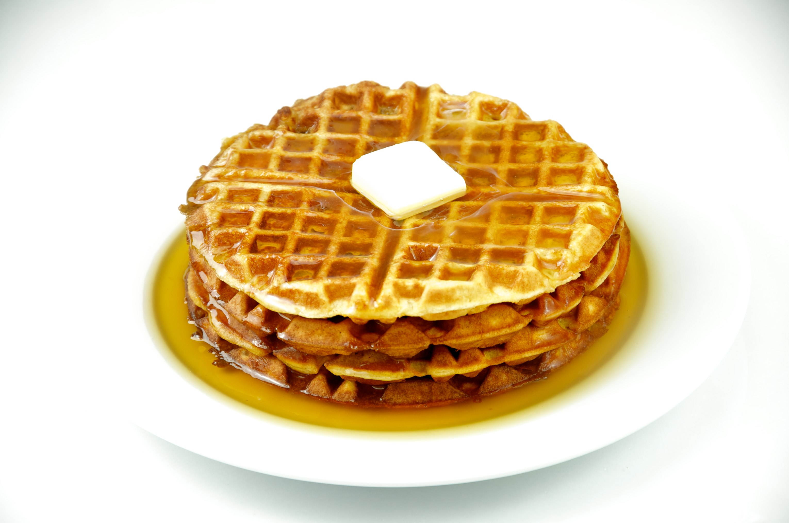
To manage accounts: www.myschoolaccount.com No breakfast on 2 hour delays *Menu Subject to Change

