Fannett-Metal School District - High School / Middle School September 2019

Fannett-Metal is an equal opportunity provider

SUNDAY | MONDAY | TUESDAY | WEDNESDAY | THURSDAY | FRIDAY | SATURDAY
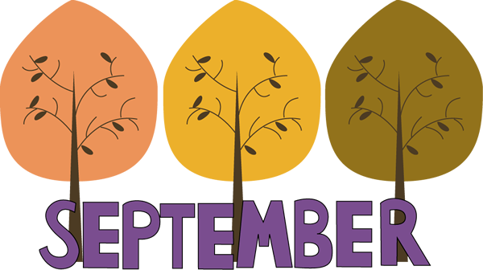 | 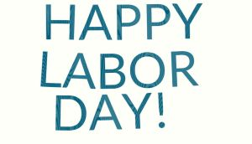 | September 3  Cheeseburger Sliders  Or  Rotisserie Chicken Wrap  Peas  Red Peppers W / Dip  Choice of Fruit / Milk | September 4  Chicken & Waffles  W / Gravy  Or  Bacon Egg & Cheese  Sandwich  Corn / Tomatoes  Choice of Fruit / Milk | September 5  Mashed Potato Bowl  W / Roll  Or  Ham & Cheese Wrap  Steamed Broccoli  Tossed Salad  Choice of Fruit / Milk | September 6  Pizza  Or  Italian Sub  Baby Carrots  Baked Beans  Choice of Fruit / Milk | Offer verses serve -  Students must take  3 of 5 items to count as a lunch & one must be a fruit or vegetable.
 | September 9  No School | September 10  No School | September 11  Pizza  Or  Cheeseburger  W/G Roll  Grape Tomatoes  Baked Beans  Choice of Fruit / Milk | September 12  General Tso’s Chicken  w/ W/G roll  Or  Grilled Ham & Cheese  Oriental Vegs/ Rice  Baby Carrots  Choice of Fruit / Milk | September 13  Pulled Pork Sandwich  Or  Turkey & Cheese Flatbread  Broccoli  Tossed Salad  Choice of Fruit / Milk | Daily Entrée options include:  Chef Or Taco Salad with whole grain roll Or Whole grain P B & J sandwich  Fruit, Vegetable & milk are included
All Meals are  served with 1% milk, fat free chocolate, fat free vanilla, fat free strawberry and skim | September 16  Cheeseburger Sub  W/G Roll  Or  BBQ Rib Sandwich  Broccoli w/ Cheese  Emoji Fries  Choice of Fruit / Milk | September 17  Walking Taco  Or  Fish Nuggets  W/G Roll  Refried Beans  Red Peppers W / Dip  Choice of Fruit / Milk | September 18  Shrimp Poppers  W / Roll  Or  Chicken Cheesesteak  Scallop Potatoes  Baby Carrots  Choice of Fruit / Milk | September 19  Stuffed Shells  Breadstick  Or  Cowboy Burger  Grape Tomatoes  Tossed Salad  Choice of Fruit / Milk | September 20  Pepperoni Pizza  Or  Meatball Sub  Peas  Baby Carrots  Choice of Fruit / Milk
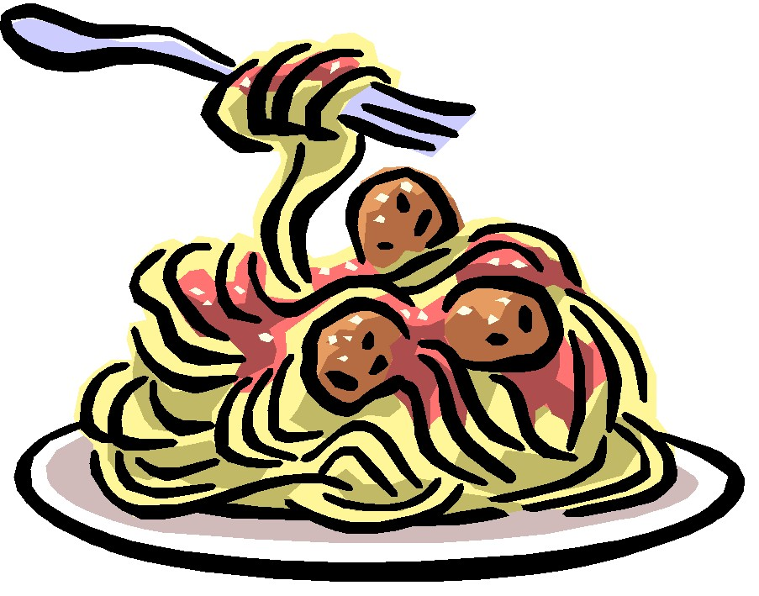 | September 23  Baked Spaghetti  Texas Toast  Or  Ham & Cheese Pretzel Roll  Romaine Salad  Peas  Choice of Fruit / Milk | September 24  Nacho Grande  Or  Turkey Club Wrap  Cheesy Broccoli  Cucumber W / Dip  Choice of Fruit / Milk | September 25  Soft Shell Tacos  Or  BBQ Chicken Sandwich  Baby Carrots  Refried Beans  Choice of Fruit / Milk | September 26  Macaroni & Cheese  Or  Calzone  Grape Tomatoes  Green Beans  Choice of Fruit / Milk | September 27  Pizza  Or  Steak & Cheese Wrap  Red Bell Peppers w/ dip  Corn  Choice of Fruit / Milk | Middle/HS Lunch-  $ 2.80  Milk - .50  Reduced - .40
No breakfast on two hour delays | September 30  Tomato Soup  Grilled Cheese  Or  Chicken Fajita  Peas  Tossed Salad  Choice of Milk / Fruit | October 1  Walking Taco  Or  Fish Nuggets  W / Roll  Refried Beans  Baby Carrots  Choice of Fruit / Milk | October 2  Cheesesteak  Or  Spicy Chicken Sandwich  Baked Beans  Celery  Choice of Fruit / Milk | October 3  Hot Turkey Sandwich  w/ gravy  Or  Hot Dog  Mashed Potato  Baby Carrots  Choice of Fruit / Milk | October 4  Pepperoni Pizza  Or  Fish Sandwich  Broccoli w/ Cheese  Grape Tomatoes  Choice of Fruit / Milk | Menu subject to change

