Fannett-Metal School District - Elementary School September 2019

Fannett-Metal is an equal opportunity provider

SUNDAY | MONDAY | TUESDAY | WEDNESDAY | THURSDAY | FRIDAY | SATURDAY
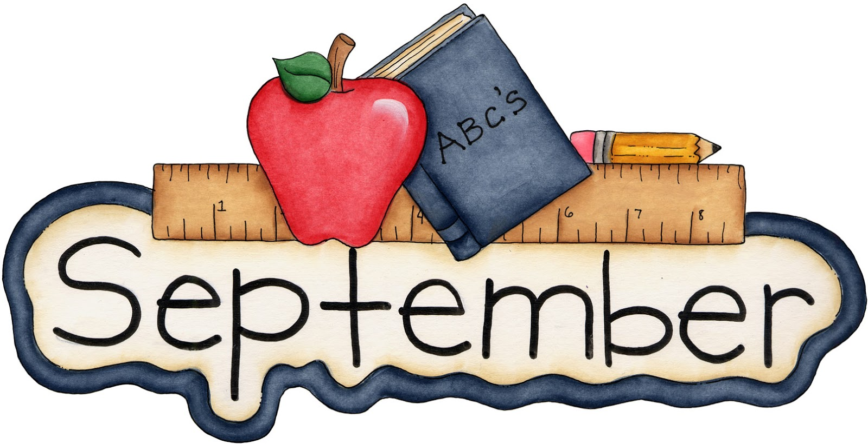 | September 2  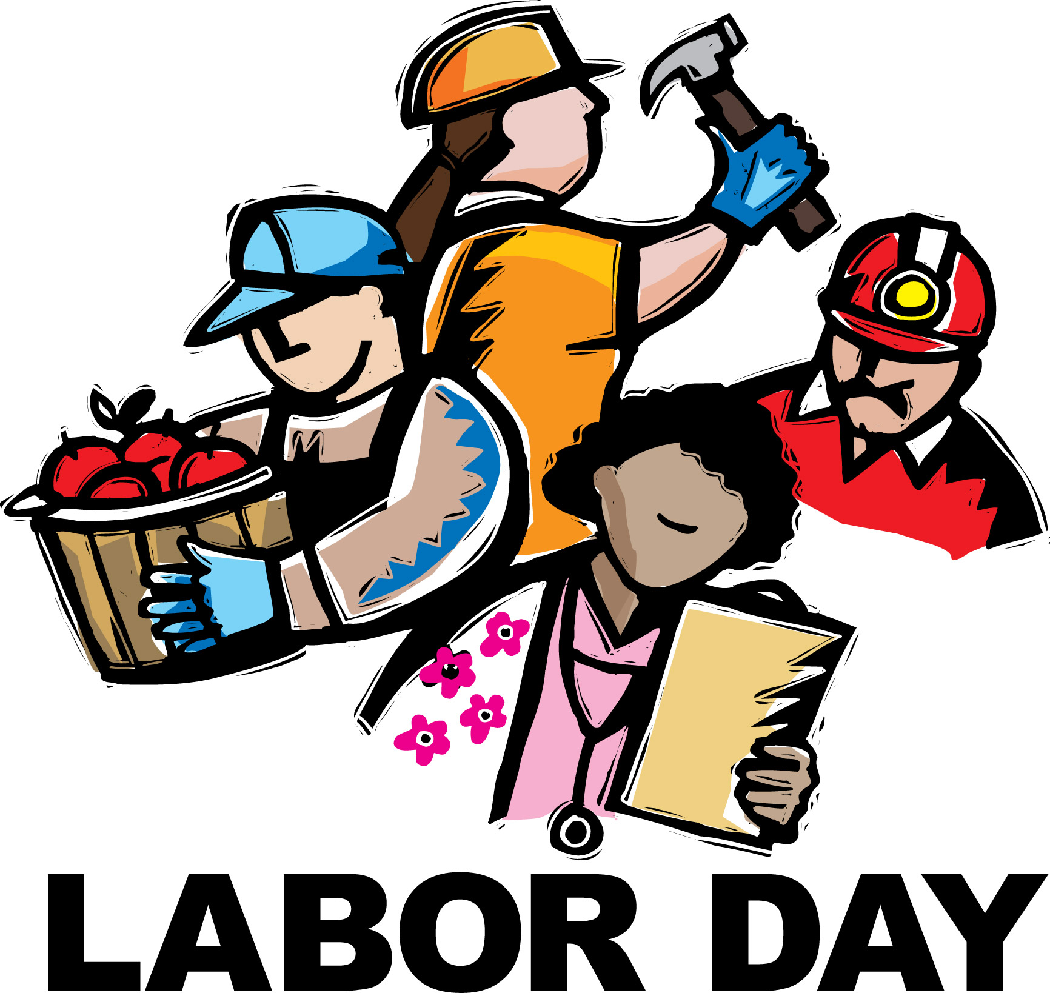 | September 3  Chicken Drum Stick  W/ Roll  Or  Hamburger  Mashed Potatoes  Baby Carrots  Choice of Fruit / Milk | September 4  Lasagna  Breadstick  Or  Grilled Ham & Cheese  Steamed Broccoli  Red Peppers W / Dip  Choice of Fruit / Milk | September 5  Mashed Potato Bowl  W/ Roll  Or  BBQ Rib Sandwich  Tossed Salad  Baked Beans  Choice of Fruit / Milk | September 6  Pizza  Or  Cheese Steak  Grape tomatoes  Scalloped Potatoes  Choice of Fruit / Milk | Offer verses serve -  Students must take  3 of 5 items to count as a lunch & one must be a fruit or vegetable.
 | September 9  No School | September 10  No School | September 11  Shrimp Poppers  W / Roll  Or  Chef Salad w/ Roll  Steamed Broccoli  Baby Carrots  Choice of Fruit / Milk | September 12  Popcorn Chicken W/ Roll  Or  Hamburger  Steamed Carrots  Romaine Salad  Choice of Fruit / Milk | September 13  Pepperoni Pizza  Or  Fish Nuggets w/ Roll  Peas  Grape tomatoes  Choice of Fruit / Milk
All Meals are  served with 1% milk, fat free chocolate, fat free vanilla, fat free strawberry and skim | September 16  Cheeseburger  Or  Calzone  Baby Carrots  Corn  Choice of Fruit / Milk | September 17  Chicken Nuggets  W / Roll  Or  Stuffed Shells W / Roll  Steamed Carrots  Celery W / Dip  Choice of Fruit / Milk | September 18  Chicken Patty  Or  Soft Shell Taco  Refried Beans  Red Peppers  Choice of Fruit / Milk | September 19  Spaghetti W/ Meatballs  Texas Toast  Or  Grilled Ham & Cheese  Steamed Broccoli  Romaine Salad  Choice of Fruit / Milk | September 20  French Bread Pizza  Or  Meatball Sub  Peas  Emoji Fries  Choice of Fruit / Milk | Pre-K Alternative  September 24th –  Chicken Nuggets W / Roll
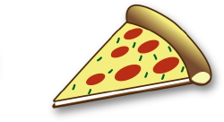 | September 23  Tomato Soup  Grilled Cheese  Or  BBQ Rib Sandwich  Tossed Salad  Steamed Carrots  Choice of Fruit / Milk | September 24  Walking Taco  Or  Hot Dog  Celery & Carrots W / Dip  Peas  Choice of Fruit / Milk | September 25  Chicken Sticks  Roll  Or  Chef Salad W / Roll  Cheesy Broccoli  Choice of Fruit / Milk | September 26  Macaroni & Cheese  Or  Fish Nuggets  W / Roll  Grape Tomatoes  Corn  Choice of Fruit / Milk | September 27  Pepperoni Pizza  Or  Shrimp Poppers W / Roll  Baked Beans  Cucumbers W / Dip  Choice of Fruit / Milk | Elementary Lunch-  $ 2.65  Milk - .50  Reduced - .40
No breakfast on two hour delays | September 30  Macaroni & Beef Pasta  Breadstick  Or  Calzone  Steamed Broccoli  Cucumbers  Choice of Fruit / Milk | October 1  Chicken Drum Stick  W/ Roll  Or  Hamburger  Mashed Potatoes  Baby Carrots  Choice of Fruit / Milk | October 2  Lasagna  Breadstick  Or  Grilled Ham & Cheese  Peas  Red Peppers W / Dip  Choice of Fruit / Milk | October 3  Mashed Potato Bowl  W/ Roll  Or  BBQ Rib Sandwich  Tossed Salad  Baked Beans  Choice of Fruit / Milk | October 4  Pizza  Or  Cheese Steak  Grape tomatoes  Scalloped Potatoes  Choice of Fruit / Milk | Menu subject to change

