Fannett-Metal School District - Elementary School April 2019

Fannett-Metal is an equal opportunity provider

SUNDAY | MONDAY | TUESDAY | WEDNESDAY | THURSDAY | FRIDAY | SATURDAY
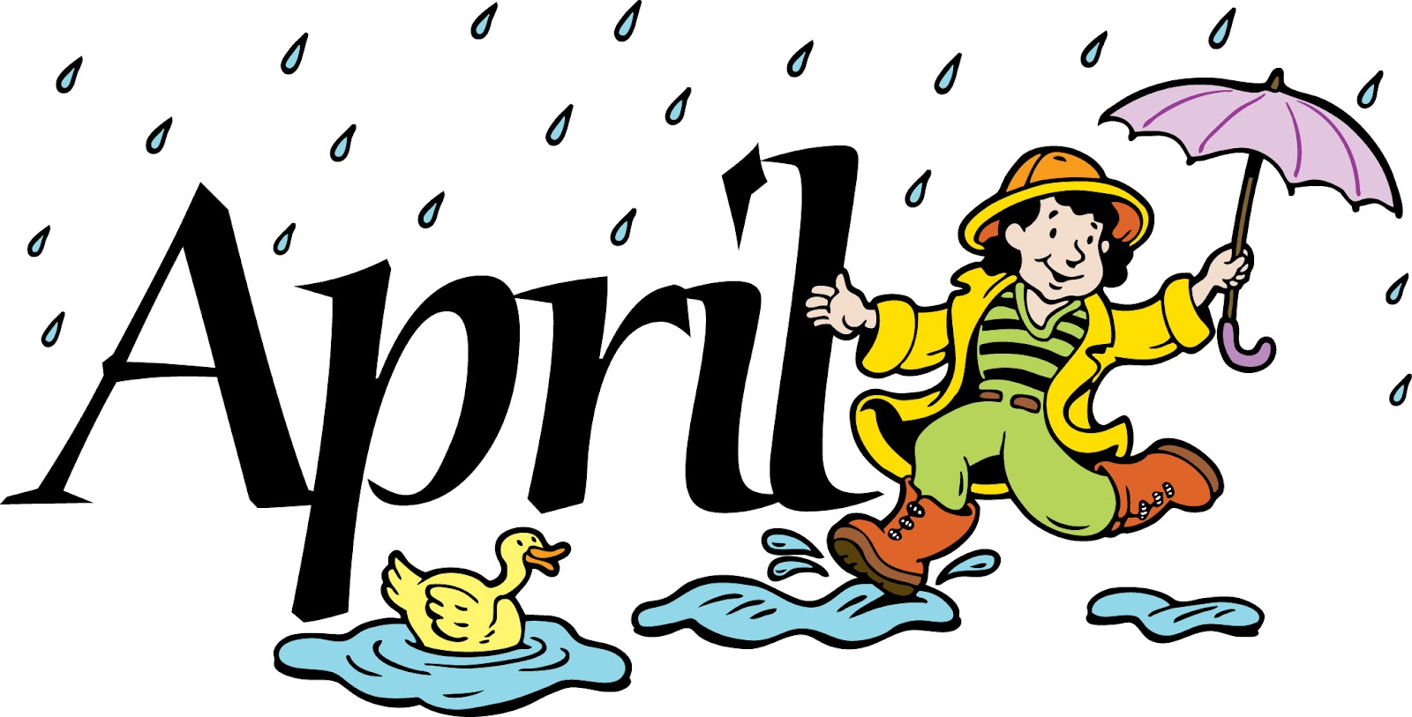 | April 1  Baked Chicken  W / Roll  Or  Cheesesteak  Mashed Potatoes  Baby Carrots  Choice of Fruit / Milk | April 2  Stuffed Shells  W / Roll  Or  Hamburger  Tossed Salad  Green Beans  Choice of Fruit / Milk | April 3  Chicken Nuggets  W / Roll  Or  Calzone  Baked Beans  Baby Carrots  Choice of Fruit / Milk | April 4  Macaroni & Cheese  W / Roll  Or  Shrimp Poppers / Roll  Peas  Red Peppers W/ Dip  Choice of Fruit / Milk | ^{April 5}  Cheese Pizza  Or  BBQ Rib Sandwich  Cheesy Broccoli  Celery Sticks W/ Dip  Choice of Fruit / Milk | Offer verses serve -  Students must take  3 of 5 items to count as a lunch & one must be a fruit or vegetable.
All Meals are  served with 1% milk, fat free chocolate, fat free vanilla, fat free strawberry and skim | April 8  Tomato soup  Grilled Cheese Sandwich  Or  Hamburger  Peas  Tossed Salad  Choice of Fruit / Milk | April 9  Walking Taco  Or  Chicken Sandwich  Broccoli  Baby Carrots  Choice of Fruit / Milk | April 10  Sweet & Sour Chicken  Noodles W/ Roll  Or  Turkey & Cheese Wrap  Tossed Salad  Green Beans  Choice of Fruit / Milk | April 11  Chicken Patty  Or  Pizza Burger  Steamed Carrots  Cucumbers w/ Dip  Choice of Fruit / Milk | April 12  Pepperoni Pizza  Or  Fish Nuggets W/ Roll  Baked Beans  Grape Tomatoes  Choice of Fruit / Milk | Pre-K Alternative:  April 23rd – Chicken Nuggets W/ Roll
 | April 15  Mashed Potato Bowl  W / Roll  Or  Chicken Cheesesteak  Steamed Carrots  Celery  Choice of Fruit / Milk | April 16  Chicken Sticks  W / Roll  Or  Calzone  Baby Carrots  Baked Beans  Choice of Fruit / Milk | April 17  Cheeseburger Sub  Or  Chef Salad W/ Roll  Cheesy Broccoli  Red Peppers W/ Dip  Choice of Fruit / Milk | April 18  Macaroni & Beef Pasta  W/ Roll  Or  Ham & Cheese Hoagie  Tossed Salad  Peas  Choice of Fruit / Milk | April 19  No School
 | April 22  BBQ Rib Sandwich  Or  Turkey & Cheese Hoagie  Steamed Carrots  Grape Tomatoes  Choice of Fruit / Milk | April 23  Spaghetti & Meatballs  W / Roll  Or  Hot Dog  Tossed Salad  Green Bean  Choice of Fruit / Milk | April 24  Chicken Patty  Or  Meatball Sub  Peas  Celery W/ Dip  Choice of Fruit / Milk | April 25  Shrimp Poppers  W/ Roll  Or  Fish Nuggets W/ Roll  Steamed Broccoli  Tossed Salad  Choice of Fruit / Milk | April 26  Pepperoni Pizza  Or  Hamburger  Corn  Baby Carrots  Choice of Fruit / Milk | Elementary-  $ 2.60  Milk - .50  Reduced - .40
PLEASE NOTE:  STUDENTS ARE NOT ABLE TO HEAT PACKED LUNCHES | April 29  Soft Shell Taco  Or  Cheesesteak  Refried Beans  Baby Carrots  Choice of Fruit / Milk | April 30  Stuffed Shells  W / Roll  Or  Hamburger  Tossed Salad  Steamed Carrots  Choice of Fruit / Milk | May 1  Chicken Nuggets  W / Roll  Or  Calzone  Baked Beans  Grape Tomatoes  Choice of Fruit / Milk | May 2  Macaroni & Cheese  W / Roll  Or  Grilled Ham & Cheese  Peas  Red Peppers W/ Dip  Choice of Fruit / Milk | May 3  Cheese Pizza  Or  BBQ Rib Sandwich  Cheesy Broccoli  Celery Sticks W/ Dip  Choice of Fruit / Milk | Menu subject to change
No Breakfast on two-hour delays

