Fannett-Metal School District - Elementary School March 2019

Fannett-Metal is an equal opportunity provider

SUNDAY | MONDAY | TUESDAY | WEDNESDAY | THURSDAY | FRIDAY | SATURDAY
 |  |  |  |  | ^{March 1}  Stuffed Crust Pizza  Or  Popcorn Chicken  W/ Goldfish Crackers  Fries / Tomatoes  Choice of Fruit / Milk | Offer verses serve -  Students must take  3 of 5 items to count as a lunch & one must be a fruit or vegetable.
All Meals are  served with 1% milk, fat free chocolate, fat free vanilla, fat free strawberry and skim | March 4  Baked Chicken  W / Roll  Or  Cheesesteak  Mashed Potatoes  Baby Carrots  Choice of Fruit / Milk | March 5  Stuffed Shells  W / Roll  Or  Hamburger  Tossed Salad  Steamed Carrots  Choice of Fruit / Milk | March 6  Chicken Nuggets  W / Roll  Or  Calzone  Baked Beans  Sliced Tomatoes  Choice of Fruit / Milk | March 7  Macaroni & Cheese  W / Roll  Or  Shrimp Poppers / Roll  Peas  Red Peppers W/ Dip  Choice of Fruit / Milk | March 8  Cheese Pizza  Or  BBQ Rib Sandwich  Cheesy Broccoli  Celery Sticks W/ Dip  Choice of Fruit / Milk | Pre-K Alternative:  March 26 – Chicken Nuggets W/ Roll
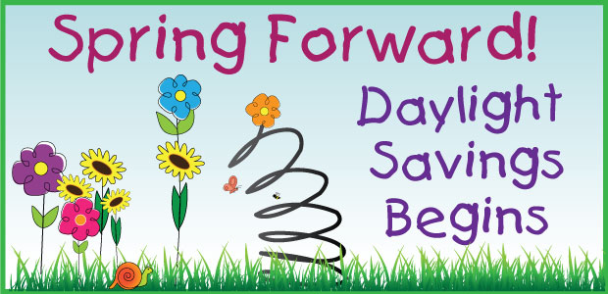 | March 11  Tomato soup  Grilled Cheese Sandwich  Or  Hamburger  Peas  Tossed Salad  Choice of Fruit / Milk | March 12  Walking Taco  Or  Chicken Sandwich  Broccoli  Baby Carrots  Choice of Fruit / Milk | March 13  Macaroni & Beef Pasta  W / Roll  Or  Turkey & Cheese Wrap  Tossed Salad  Green Beans  Choice of Fruit / Milk | March 14  Chicken Patty  Or  Pizza Burger  Steamed Carrots  Cucumbers w/ Dip  Choice of Fruit / Milk | March 15  Pepperoni Pizza  Or  Fish Nuggets W/ Roll  Baked Beans  Celery W/ Dip  Choice of Fruit / Milk
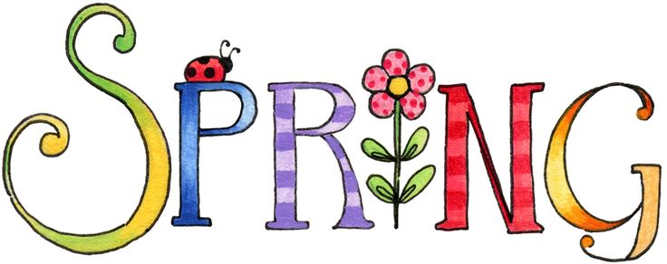 | March 18  Mashed Potato Bowl  W / Roll  Or  Chicken Cheesesteak  Steamed Carrots  Celery  Choice of Fruit / Milk | March 19  Chicken Sticks  W / Roll  Or  Calzone  Tossed Salad  Baked Beans  Choice of Fruit / Milk | March 20  Cheeseburger Sub  Or  Chef Salad W/ Roll  Cheesy Broccoli  Red Peppers W/ Dip  Choice of Fruit / Milk | March 21  Roast Turkey  W/ Gravy & Roll  Or  Ham & Cheese Hoagie  Mashed Potatoes  Corn  Choice of Fruit / Milk | March 22  Hamburger  Or  BBQ Chicken Sandwich  Peas  Baby Carrots  Choice of Fruit / Milk | Elementary-  $ 2.60  Milk - .50  Reduced - .40
PLEASE NOTE:  STUDENTS ARE NOT ABLE TO HEAT PACKED LUNCHES | March 25  BBQ Rib Sandwich  Or  Turkey & Cheese Hoagie  Steamed Carrots  Grape Tomatoes  Choice of Fruit / Milk | March 26  Spaghetti & Meatballs  W / Roll  Or  Hot Dog  Tossed Salad  Green Bean  Choice of Fruit / Milk | March 27  Chicken Patty  Or  Meatball Sub  Peas  Celery W/ Dip  Choice of Fruit / Milk | March 28  Chicken Alfredo  Breadstick  Or  Cheeseburger  Steamed Broccoli  Baby Carrots  Choice of Fruit / Milk | March 29  Stuffed Crust Pizza  Or  Fish Sandwich  Baked Beans  Grape Tomatoes  Choice of Fruit / Milk | Menu subject to change
No Breakfast on two-hour delays

