Fannett-Metal School District - High School / Middle School January 2019

Fannett-Metal is an equal opportunity provider

SUNDAY | MONDAY | TUESDAY | WEDNESDAY | THURSDAY | FRIDAY | SATURDAY
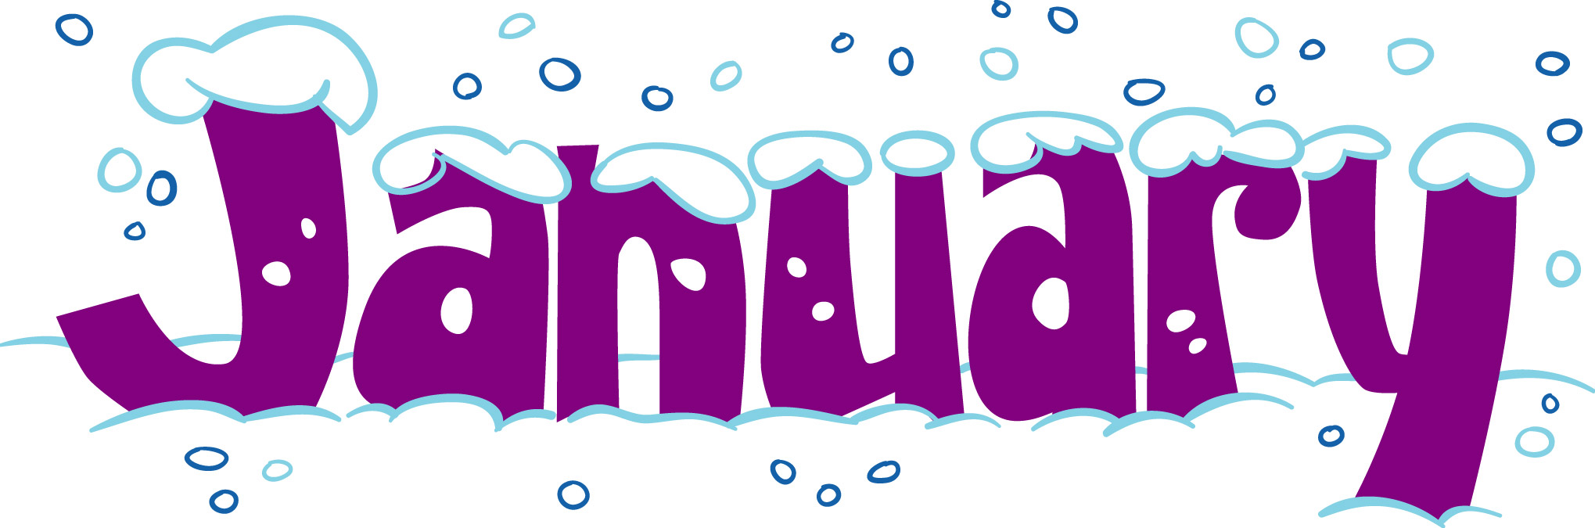 |  | January 1  No School | January 2  Nacho Grande  Or  Chicken Cheesesteak  Broccoli  Baby Carrots  Choice of Fruit / Milk | January 3  Chicken Parmesan  Over Noodles  Or  Shrimp Poppers w/ Roll  Steamed Carrots  Tossed Salad  Choice of Fruit / Milk | January 4  Pepperoni Pizza  Or  Chicken Parmesan  Sandwich  Grape Tomatoes  Peas  Choice of Fruit / Milk | Offer verses serve -  Students must take  3 of 5 items to count as a lunch & one must be a fruit or vegetable.
 | January 7  Tomato soup  Grilled Cheese Sandwich  Or  Rotisserie Chicken Wrap  Steamed Carrots  Tossed Salad  Choice of Fruit / Milk | January 8  Mashed Potato Bowl  W/ Roll  Or  Cheeseburger  Grape Tomatoes  Broccoli  Choice of Fruit / Milk | January 9  Chicken Patty  Sandwich  Or  Turkey Club Wrap  Baked Beans  Baby Carrots  Choice of Fruit / Milk | January 10  General Tso’s Chicken  W/ Roll  Or  Ham, Egg & Cheese  Sandwich  Peas / Egg Roll  Tossed Salad  Choice of Fruit / Milk | January 11  Buffalo Chicken Pizza  Or  Turkey & Cheese  Hoagie  Tatar Tots  Grape Tomatoes  Choice of Fruit / Milk | Daily Entrée options include:  Chef Or Chicken Salad with whole grain roll Or Whole grain P B & J sandwich  Fruit, Vegetable & milk are included
All Meals are  served with 1% milk, fat free chocolate, fat free vanilla, fat free strawberry and skim | January 14  Baked Spaghetti  Texas Toast  Or  Chicken Sandwich  Tossed Salad  Green Beans  Choice of Fruit / Milk | January 15  Walking Taco  Or  Calzone  Refried Beans  Grape Tomatoes  Choice of Fruit / Milk | January 16  Spicy Chicken Patty  Or  Cheesesteak  Celery w/ dip  Steamed Carrots  Choice of Fruit / Milk | January 17  Chicken Alfredo  Breadstick  Or  Hamburger  Tossed Salad  Broccoli  Choice of Fruit / Milk | January 18  Cheese Pizza  Or  Fish Nuggets W/ Roll  Peas  Baby Carrots  Choice of Fruit / Milk
No breakfast on two hour delays | January 21  No School | January 22  Cowboy Burger  Or  Chicken Sandwich  Baked Beans  Celery W/ Dip  Choice of Fruit / Milk | January 23  Pulled Pork Sandwich  Or  Meatball Sub  Peas  Grape Tomatoes  Choice of fruit / Milk | January 24  Hot Turkey Sandwich  Or  Ham & Cheese Wrap  French Fries  Baby Carrots  Choice of Fruit / Milk | January 25  Cheeseburger Sub  Or  Fish Sandwich  Green Beans  Grape Tomatoes  Choice of Fruit / Milk | Middle/HS Lunch-  $ 2.75  Milk - .50  Reduced - .40
 | January 28  Chicken Noodle Soup  BBQ Rib Sandwich  Or  Turkey & Cheese on Flatbread  Celery / Tomatoes  Choice of Fruit / Milk | January 29  Hamburger  Or  Hot dog  Baked Beans  Tossed Salad  Choice of Fruit / Milk | January 30  Nacho Grande  Or  Chicken Cheesesteak  Broccoli  Baby Carrots  Choice of Fruit / Milk | January 31  Chicken Parmesan  Over Noodles  Or  Shrimp Poppers w/ Roll  Peas  Tossed Salad  Choice of Fruit / Milk | February 1  Pepperoni Pizza  Or  Chicken Parmesan Sandwich  Grape Tomatoes  Steamed Carrots  Choice of Fruit / Milk | Menu subject to change

