Fannett-Metal School District - Elementary School January 2019

Fannett-Metal is an equal opportunity provider

SUNDAY | MONDAY | TUESDAY | WEDNESDAY | THURSDAY | FRIDAY | SATURDAY
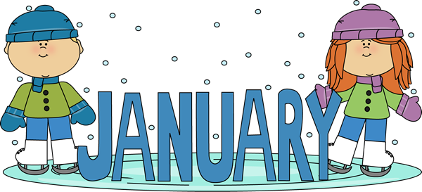 |  | January 1  No School | January 2  Chicken Patty  Or  Cheeseburger  Peas  Tossed Salad  Choice Fruit / Milk | January 3  Chicken Alfredo  Breadstick  Or  Chef Salad W / Roll  Steamed Broccoli  Baby Carrots  Choice of Fruit / Milk | ^{January 4}  Cheese Pizza  Or  Fish Sandwich  Sweet Potato Fries  Celery W/ Dip  Choice of Fruit / Milk | Offer verses serve -  Students must take  3 of 5 items to count as a lunch & one must be a fruit or vegetable.
 | January 7  Baked Chicken  Roll  Or  Cheesesteak  Emoji Fries  Baby Carrots  Choice of Fruit / Milk | January 8  Stuffed Shells  Roll  Or  Hamburger  Tossed Salad  Steamed Carrots  Choice of Fruit / Milk | January 9  Chicken Nuggets  Roll  Or  Calzone  Baked Beans  Baby Carrots  Choice of Fruit / Milk | January 10  Macaroni & Cheese  Roll  Or  Shrimp Poppers / Roll  Peas  Grape Tomatoes  Choice of Fruit / Milk | January 11  Cheese Pizza  Or  BBQ Rib Sandwich  Broccoli  Celery Sticks W/ Dip  Choice of Fruit / Milk
All Meals are  served with 1% milk, fat free chocolate, fat free vanilla, fat free strawberry and skim | January 14  Tomato soup  Grilled Cheese Sandwich  Or  Hamburger  Peas  Tossed Salad  Choice of Fruit / Milk | January 15  Walking Taco  Or  Chicken Sandwich  Broccoli  Baby Carrots  Choice of Fruit / Milk | January 16  Lasagna  Roll  Or  Turkey & Cheese Wrap  Tossed Salad  Green Beans  Choice of Fruit / Milk | January 17  Mashed Potato Bowl  W/ Roll  Or  Fish Sandwich  Steamed Carrots  Grape Tomatoes  Choice of Fruit / Milk | January 18  Chicken Patty  Or  Calzone  Baked Beans  Baby Carrots  Choice of Fruit / Milk | Pre-K Alternative:  Jan. 29th – chicken Nuggets w/ roll
 | January 21  No School | January 22  Chicken Sticks  Roll  Or  Fish Nuggets  Tossed Salad  Baked Beans  Choice of Fruit / Milk | January 23  Macaroni & Beef Pasta  Roll  Or  Chef Salad W/ Roll  Cheesy Broccoli  Grape Tomatoes  Choice of Fruit / Milk | January 24  Hot Turkey Sandwich  Or  Ham & Cheese Hoagie  Emoji Fries  Baby Carrots  Choice of Fruit / Milk | January 25  Cheeseburger  Or  Chicken Sandwich  Green Beans  Celery w/ dip  Choice of Fruit / Milk | Elementary-  $ 2.60  Milk - .50  Reduced - .40
PLEASE NOTE:  STUDENTS ARE NOT ABLE TO HEAT PACKED LUNCHES | January 28  Chicken Noodle Soup  BBQ Rib Sandwich  Or  Turkey & Cheese Hoagie  Steamed Carrots  Grape Tomatoes  Choice of Fruit / Milk | January 29  Hamburger  Or  Hot Dog  Baked Beans  Corn on Cob  Choice of Fruit / Milk | January 30  Chicken Patty  Or  Meatball Sub  Peas  Tossed Salad  Choice of Fruit / Milk | January 31  Chicken Alfredo  Breadstick  Or  Shrimp Poppers  Steamed Broccoli  Baby Carrots  Choice of Fruit / Milk | February 1  Stuffed Crust Pizza  Or  Sloppy Joe Sandwich  Peas  Grape Tomatoes  Choice of Fruit / Milk | Menu subject to change
No Breakfast on two-hour delays

