Fannett-Metal School District - High School / Middle School December 2018

Fannett-Metal is an equal opportunity provider

SUNDAY | MONDAY | TUESDAY | WEDNESDAY | THURSDAY | FRIDAY | SATURDAY
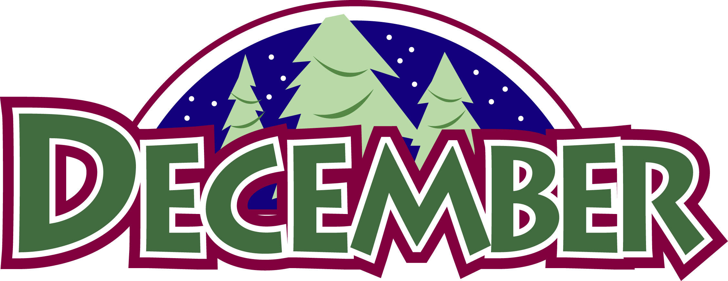 | December 3  Tomato Soup  Grilled Cheese Sandwich  Or  Rotisserie Chicken Wrap  Steamed Carrots  Tossed Salad  Choice of Fruit / Milk | December 4  Hot Turkey Sandwich  W/ Gravy  Or  Ham & Cheese Wrap  Emoji Fries  Baby Carrots  Choice of Fruit / Milk | December 5  Cowboy Burger  Or  Pulled Pork  Baked Beans  Celery W/ Dip  Choice of Fruit / Milk | December 6  Spaghetti and Meatballs  W/G Roll  Or  Shrimp Poppers w/ Roll  Peas  Romaine Salad  Choice of Fruit / Milk | December 7  Pepperoni Pizza  Or  Meatball Sub  Green Beans  Baby Carrots  Choice of Fruit / Milk | Offer verses serve -  Students must take  3 of 5 items to count as a lunch & one must be a fruit or vegetable.
 | December 10  Chicken Noodle Soup  BBQ Rib Sandwich  Or  Tukey & Cheese on Flatbread  Celery w/ dip  Steamed Carrots  Choice of Fruit / Milk | December 11  Mashed Potato Bowl  W/ Roll  Or  Cheeseburger  Cucumbers W/ Dip  Broccoli  Choice of Fruit / Milk | December 12  Chicken Patty  Sandwich  Or  Turkey Club Wrap  Baked Beans  Baby Carrots  Choice of Fruit / Milk | December 13  General Tso’s Chicken  W/ Roll  Or  Ham, Egg & Cheese  Sandwich  Peas / Egg Roll  Tossed Salad  Choice of Fruit / Milk | December 14  Buffalo Chicken Pizza  Or  Turkey & Cheese  Hoagie  Tatar Tots  Baby Carrots  Choice of Fruit / Milk | Daily Entrée options include:  Chef Or Chicken Salad with whole grain roll Or Whole grain P B & J sandwich  Fruit, Vegetable & milk are included
All Meals are  served with 1% milk, fat free chocolate, fat free vanilla, fat free strawberry and skim | December 17  Baked Spaghetti  Texas Toast  Or  Chicken Sandwich  Tossed Salad  Green Beans  Choice of Fruit / Milk | December 18  Cheeseburger Sliders  Or  Fish Nuggets W/ Roll  Refried Beans  Baby Carrots  Choice of Fruit / Milk | December 19  Breakfast Bowl  W/ Biscuit  Or  Cheesesteak  Hash Brown  Steamed Carrots  Choice of Fruit / Milk | December 20  Chicken Alfredo  Breadstick  Or  Hamburger  Tossed Salad  Broccoli  Choice of Fruit / Milk | December 21  Cheese Pizza  Or  Rotisserie Chicken Wrap  Peas  Baby Carrots  Choice of Fruit / Milk
No breakfast on two hour delays | December 24 | December 25 | December 26  No School | December 27  No School | December 28  No School | Middle/HS Lunch-  $ 2.75  Milk - .50  Reduced - .40
 | December 31  No School | January 1 | January 2  Nacho Grande  Or  Chicken Cheesesteak  Broccoli  Baby Carrots  Choice of Fruit / Milk | January 3  Chicken Parmesan  Over Noodles  Or  Shrimp Poppers w/ Roll  Peas  Romaine Salad  Choice of Fruit / Milk | January 4  Pepperoni Pizza  Or  Chicken Parmesan Sandwich  Grape Tomatoes  Steamed Carrots  Choice of Fruit / Milk | Menu subject to change

