Fannett-Metal School District - Elementary School December 2018

Fannett-Metal is an equal opportunity provider

SUNDAY | MONDAY | TUESDAY | WEDNESDAY | THURSDAY | FRIDAY | SATURDAY
 | December 3  Cheeseburger  Or  Turkey & Cheese Wrap  Baked Beans  Red Peppers w/ Dip  Choice of Fruit / Milk | December 4  Turkey & Gravy  Or  Chef Salad W/ Roll  Mashed Potatoes  Corn  Choice of Fruit / Milk | December 5  Popcorn Chicken  Roll  Or  BBQ Rib Sandwich  Cheesy Broccoli  Tossed Salad  Choice Fruit / Milk | December 6  Spaghetti and Meatballs  Breadstick  Or  Grilled Chicken Sandwich  Peas / Baby Carrots  Choice of Fruit / Milk | ^{December 7}  Pepperoni Pizza  Or  Meatball Sub  Sweet Potato Fries  Celery W/ Dip  Choice of Fruit / Milk | Offer verses serve -  Students must take  3 of 5 items to count as a lunch & one must be a fruit or vegetable.
 | December 10  Baked Chicken  Roll  Or  Cheesesteak  Emoji Fries  Baby Carrots  Choice of Fruit / Milk | December 11  Stuffed Shells  Roll  Or  Hamburger  Tossed Salad  Steamed Carrots  Choice of Fruit / Milk | December 12  Chicken Nuggets w/ Roll  Or  Ham & Cheese Wrap  Baked Beans  Scalloped Potatoes  Choice of Fruit / Milk | December 13  Macaroni & Cheese  Roll  Or  Shrimp Poppers / Roll  Peas  Cucumbers  Choice of Fruit / Milk | December 14  Cheese Pizza  Or  Chicken Sticks W/ Roll  Broccoli  Celery Sticks W/ Dip  Choice of Fruit / Milk
All Meals are  served with 1% milk, fat free chocolate, fat free vanilla, fat free strawberry and skim | December 17  Tomato soup  Grilled Cheese Sandwich  Or  Chicken Fajita  Peas  Tossed Salad  Choice of Fruit / Milk | December 18  Walking Taco  Or  Chicken Cheesesteak  Broccoli  Baby Carrots  Choice of Fruit / Milk | December 19  Chicken Tenders  W/ Roll  Or  Turkey & Cheese Wrap  Corn  Celery w/ dip  Choice of Fruit / Milk | December 20  Mashed Potato Bowl  W/ Roll  Or  Fish Sandwich  Steamed Carrots  Sliced Tomatoes  Choice of Fruit / Milk | December 21  Chicken Patty  Or  Calzone  Peas  Baby Carrots  Choice of Fruit / Milk | Pre-K Alternative:  NONE
 | December 24 | December 25  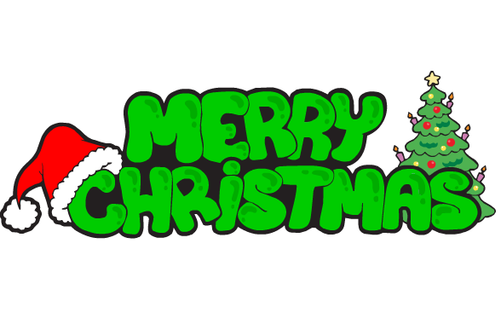 | December 26  No School | December 27  No School | December 28  No School | Elementary-  $ 2.60  Milk - .50  Reduced - .40
PLEASE NOTE:  STUDENTS ARE NOT ABLE TO HEAT PACKED LUNCHES | December 31  No School | January 1 | January 2  Chicken Patty  Or  Cheeseburger  Peas  Tossed Salad  Choice of Fruit / Milk | January 3  Chicken Alfredo  Breadstick  Or  Chef Salad W/ Roll  Steamed Broccoli  Baby Carrots  Choice of Fruit / Milk | ^{January 4}  Cheese Pizza  Or  Fish Sandwich  Baked Beans  Grape Tomatoes  Choice of Fruit / Milk | Menu subject to change
No Breakfast on two-hour delays

