Fannett-Metal School District – Elementary December 2018
USDA Nondiscrimination Statement and Complaint Procedure
The U.S Department of Agriculture prohibits discrimination against its customers, employees, and applicants for employment on the bases of race, color, national origin, age, disability, sex, gender identity, religion, reprisal, and where applicable, political beliefs, marital status, familial or parental status, sexual orientation, or if all or part of an individual's income is derived from any public assistance program, or protected genetic information in employment or in any program or activity conducted or funded by the Department. (Not all prohibited bases will apply to all programs and/or employment activities.)
If you wish to file a Civil Rights program complaint of discrimination, complete the USDA Program Discrimination Complaint Form, found online at http://www.ascr.usda.gov/complaint_filing_cust.html, or at any USDA office, or call (866) 632-9992 to request the form. You may also write a letter containing all of the information requested in the form. Send your completed complaint form or letter to us by mail at U.S. Department of Agriculture, Director, Office of Adjudication, 1400 Independence Avenue, S.W., Washington, D.C. 20250-9410, by fax (202) 690-7442 or email at program.intake@usda.gov .
Individuals who are deaf, hard of hearing or have speech disabilities may contact USDA through the Federal Relay Service at (800) 877-8339; or (800) 845-6136 (Spanish
Fannett-Metal is an equal opportunity provider

SUNDAY | MONDAY | TUESDAY | WEDNESDAY | THURSDAY | FRIDAY | SATURDAY
 | December 3  French Toast Sticks  Or  Cereal  Whole Grain Bread  Fruit / Vegetable  Milk / Juice | December 4  Funnel Cake  Or  Cereal Bar & Yogurt  Whole Grain Bread  Fruit / Vegetable  Milk / Juice | December 5  Waffles &  Sausage Patty  Or  Cereal  Whole Grain Bread  Fruit / Vegetable  Milk / Juice | December 6  Breakfast Pizza  Or  Cereal Bar & Yogurt  Whole Grain Bread  Fruit / Vegetable  Milk / Juice | December 7  Cinnamon Bun  Or  Cereal  Whole Grain Bread  Fruit / Vegetable  Milk / Juice | Offer verses serve -  Students must take  3 of 5 items to count as a lunch & one must be a fruit or vegetable.
 | December 10  French Toast Sticks  Or  Cereal  Whole Grain Bread  Fruit / Vegetable  Milk / Juice | December 11  Funnel Cake  Or  Cereal Bar & Yogurt  Whole Grain Bread  Fruit / Vegetable  Milk / Juice | December 12  Waffles &  Sausage Patty  Or  Cereal  Whole Grain Bread  Fruit / Vegetable  Milk / Juice | December 13  Breakfast Pizza  Or  Cereal Bar & Yogurt  Whole Grain Bread  Fruit / Vegetable  Milk / Juice | December 14  Cinnamon Bun  Or  Cereal  Whole Grain Bread  Fruit / Vegetable  Milk / Juice | Menu subject to change
All Meals are  served with 1% milk, fat free chocolate, fat free vanilla, fat free strawberry and skim | December 17  French Toast Sticks  Or  Cereal  Whole Grain Bread  Fruit / Vegetable  Milk / Juice | December 18  Funnel Cake  Or  Cereal Bar & Yogurt  Whole Grain Bread  Fruit / Vegetable  Milk / Juice | December 19  Waffles &  Sausage Patty  Or  Cereal  Whole Grain Bread  Fruit / Vegetable  Milk / Juice | December 20  Breakfast Pizza  Or  Cereal Bar & Yogurt  Whole Grain Bread  Fruit / Vegetable  Milk / Juice | December 21  Cinnamon Bun  Or  Cereal  Whole Grain Bread  Fruit / Vegetable  Milk / Juice | 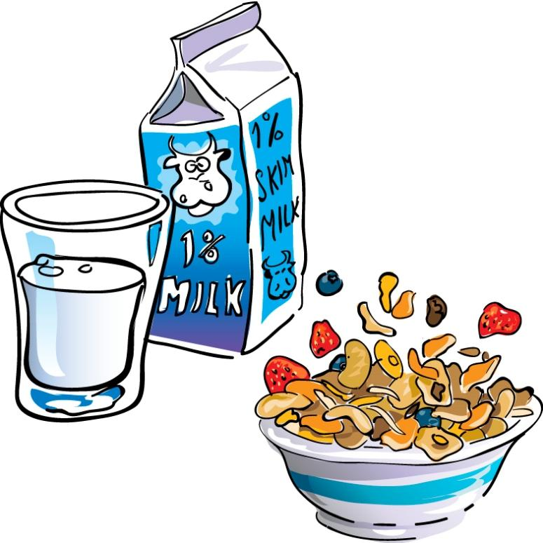
 | December 24 | December 25 | December 26  No School | December 27  No School | December 28  No School | Elementary Breakfast  $ 1.55  Milk - .50  Reduced - .40
No breakfast on two hour delays | December 31  No School | January 1 | January 2  Waffles &  Sausage Patty  Or  Cereal  Whole Grain Bread  Fruit / Vegetable  Milk / Juice | January 3  Breakfast Pizza  Or  Cereal Bar & Yogurt  Whole Grain Bread  Fruit / Vegetable  Milk / Juice | January 4  Cinnamon Bun  Or  Cereal  Whole Grain Bread  Fruit / Vegetable  Milk / Juice

