Fannett-Metal School District - High School / Middle School November 2018

Fannett-Metal is an equal opportunity provider

SUNDAY | MONDAY | TUESDAY | WEDNESDAY | THURSDAY | FRIDAY | SATURDAY
 |  |  |  | November 1  Spaghetti and Meatballs  W/G Roll  Or  Shrimp Poppers w/ Roll  Peas  Romaine Salad  Choice of Fruit / Milk | November 2  Pepperoni Pizza  Or  Meatball Sub  Green Beans  Baby Carrots  Choice of Fruit / Milk | Offer verses serve -  Students must take  3 of 5 items to count as a lunch & one must be a fruit or vegetable.
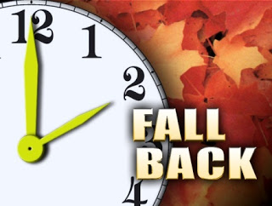 | November 5  Chicken Noodle Soup  BBQ Rib Sandwich  Or  Tukey & Cheese on Pretzel Roll  Celery w/ dip  Steamed Carrots  Choice of Fruit / Milk | November 6  Mashed Potato Bowl  W/ Roll  Or  Cheeseburger  Cucumbers W/ Dip  Baked Beans  Choice of Fruit / Milk | November 7  Chicken Patty  Sandwich  Or  Turkey Club Wrap  Cheesy Broccoli  Baby Carrots  Choice of Fruit / Milk | November 8  General Tso’s Chicken  Or  Hot Dog  Oriental Vegetables  Rice  Egg Roll/ Fortune Cookie  Choice of Fruit / Milk | November 9  No School | Daily Entrée options include:  Chef Or Chicken Salad with whole grain roll Or Whole grain P B & J sandwich  Fruit, Vegetable & milk are included
All Meals are  served with 1% milk, fat free chocolate, fat free vanilla, fat free strawberry and skim | November 12  NO SCHOOL | November 13  Walking Taco  Or  Chicken Sandwich  Refried Beans  Baby Carrots  Choice of Fruit / Milk | November 14  Cheesesteak  Or  Pulled Pork Sandwich  Celery w/ Dip  Steamed Carrots  Choice of Fruit / Milk | November 15  Chicken Alfredo  Breadstick  Or  Pizza Burger  Tossed Salad  Broccoli  Choice of Fruit / Milk | November 16  Cheese Pizza  Or  Rotisserie Chicken Wrap  Peas  Baby Carrots  Choice of Fruit / Milk
No breakfast on two hour delays | November 19  Baked Spaghetti  Texas Toast  Or  BBQ Chicken Sandwich  Tossed Salad  Peas/ Tomatoes  Choice of Fruit / Milk | November 20  Roast Turkey  W/ Roll  Or  Ham Egg & Cheese Pretzel Roll  Mashed Potatoes  Stuffing / Corn  Choice of Fruit / Milk | November 21  Breaded Pork Chop  Roll  Or  Chicken Fajitas  Cheesy Broccoli  Baby Carrots  Choice of Fruit / Milk | November 22  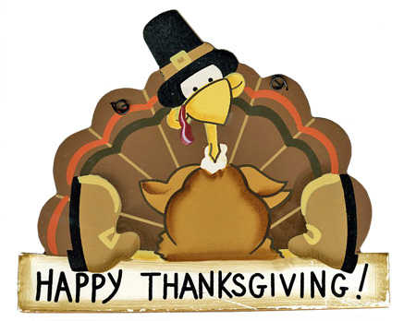 | November 23  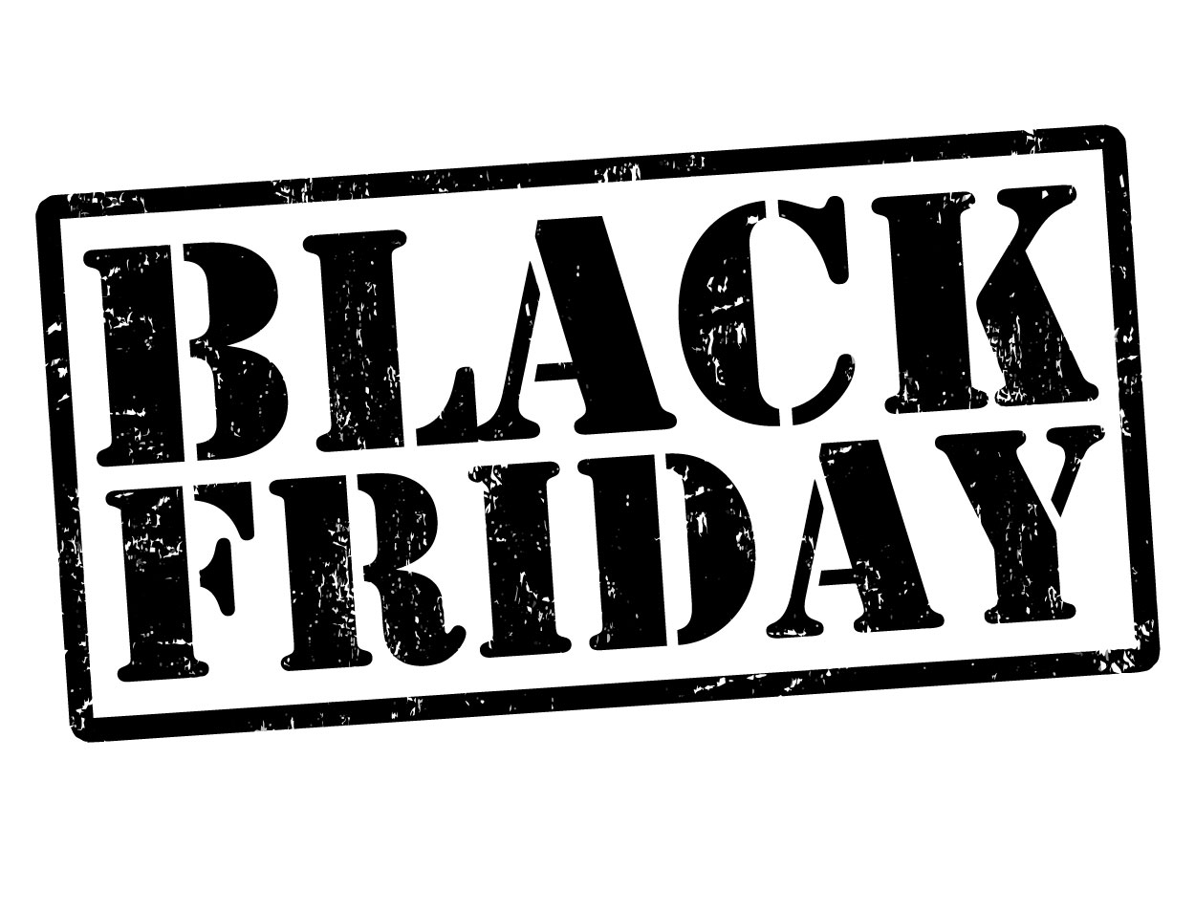 | Middle/HS Lunch-  $ 2.75  Milk - .50  Reduced - .40
 | November 26  No School | November 27  No School | November 28  Nacho Grande  Or  Chicken Cheesesteak  Broccoli  Cucumbers W/ Dip  Choice of Fruit / Milk | November 29  Chicken Parmesan  Over Noodles  Or  Shrimp Poppers w/ Roll  Peas  Romaine Salad  Choice of Fruit / Milk | November 30  Pepperoni Pizza  Or  Meatball Sub  Celery w/ Dip  Steamed Carrots  Choice of Fruit / Milk | Menu subject to change

