Fannett-Metal School District - Elementary School November 2018

Fannett-Metal is an equal opportunity provider

SUNDAY | MONDAY | TUESDAY | WEDNESDAY | THURSDAY | FRIDAY | SATURDAY
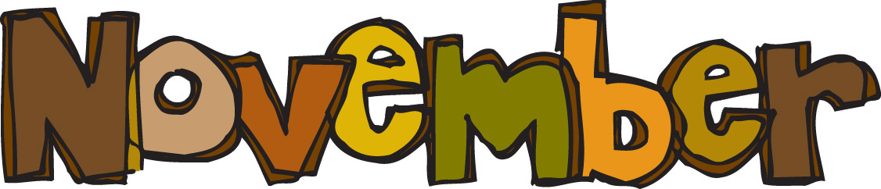 |  |  |  | November 1  Chicken & Waffles  W/ Gravy  Or  Fish Nuggets W/ Roll  Red Peppers w/ Dip  Peas  Choice of Fruit / Milk | ^{November 2}  Cheeseburger  Or  Calzone  Baked Beans  Celery W/ Dip  Choice of Fruit / Milk | Offer verses serve -  Students must take  3 of 5 items to count as a lunch & one must be a fruit or vegetable.
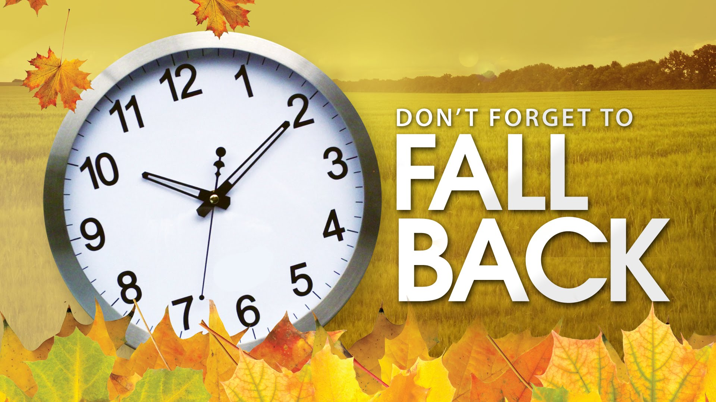 | November 5  Chicken Noodle Soup  Grilled Ham & Cheese  Or  Pizza Burger  Baked Beans  Red Peppers w/ Dip  Choice of Fruit / Milk | November 6  Holiday Meal  Roast Turkey  Roll  Mashed Potatoes  Corn/Stuffing/ Gravy  Or Hot Dog  Choice of Fruit / Milk | November 7  BBQ Rib Sandwich  Or  Chicken Fajita  Broccoli  Tossed Salad  Choice Fruit / Milk | November 8  Spaghetti and Meatballs  Breadstick  Or  Grilled Chicken Sandwich  Peas / Baby Carrots  Choice of Fruit / Milk | November 9  No School
All Meals are  served with 1% milk, fat free chocolate, fat free vanilla, fat free strawberry and skim | November 12  No School | November 13  Lasagna W/ Roll  Or  Turkey & Cheese  Pretzel Roll  Tossed Salad  Steamed Carrots  Choice of Fruit / Milk | November 14  Chicken Nuggets w/ Roll  Or  Cheese Steak  Baked Beans  Red Peppers w/ Dip  Choice of Fruit / Milk | November 15  Chicken Patty  Or  Meatball Sub  Peas  Baby Carrots  Choice of Fruit / Milk | November 16  Cheese Pizza  Or  Grilled Chicken & Cheese Wrap  Cheesy Broccoli  Celery Sticks W/ Dip  Choice of Fruit / Milk | Pre-K Alternative  Nov. 6th – Chicken Sticks w/ Roll
 | November 19  Tomato soup  Grilled Cheese Sandwich  Or  Cheeseburger  Peas  Tossed Salad  Choice of Fruit / Milk | November 20  Walking Taco  Or  Grilled Chicken Sandwich  Broccoli  Baby Carrots  Choice of Fruit / Milk | November 21  Mashed Potato Bowl  W/ Roll  Or  Fish Sandwich  Steamed Carrots  Sliced Tomatoes  Choice of Fruit / Milk | November 22  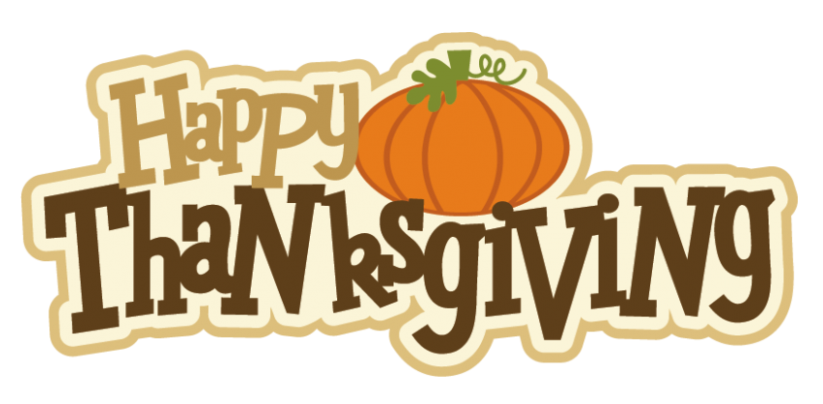 | November 23  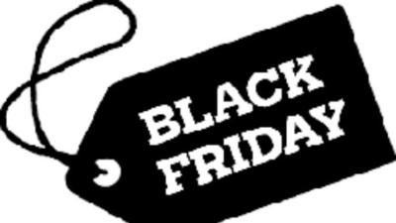 | Elementary-  $ 2.60  Milk - .50  Reduced - .40
PLEASE NOTE:  STUDENTS ARE NOT ABLE TO HEAT PACKED LUNCHES | November 26  No School | November 27  No School | November 28  Chicken Patty  Or  Ham & Cheese on  Goldfish shaped bread  Red Peppers W/ Dip  Peas  Choice of Fruit / Milk | November 29  Chicken Alfredo  W/ Roll  Or  Chef Salad w/ Roll  Steamed Broccoli  Baby Carrots  Choice of Fruit / Milk | ^{November 30}  Cheeseburger  Or  Shrimp Poppers w/ Roll  Baked Beans  Tossed Salad  Choice of Fruit / Milk | Menu subject to change
No Breakfast on two-hour delays

