Fannett-Metal School District - Elementary School September 2018

Fannett-Metal is an equal opportunity provider

SUNDAY | MONDAY | TUESDAY | WEDNESDAY | THURSDAY | FRIDAY | SATURDAY
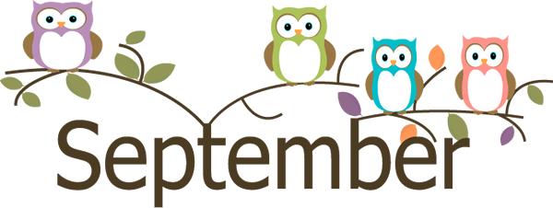 | September 3  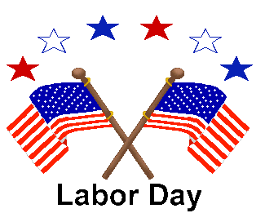 | September 4  Chicken Patty Sandwich  Or  Pizza Burger  Smiley Fries  Sliced Tomatoes  Choice of Fruit / Milk | September 5  Popcorn Chicken W/ Roll  Or  Chef Salad w/ Roll  Steamed Broccoli  Baby Carrots  Choice of Fruit / Milk | September 6  Sweet & Sour Chicken  W/G Roll  Or  Hamburger  Peas  Rice  Choice of Fruit / Milk | ^{September 7}  Cheeseburger  Or  Calzone  Baked Beans  Grape Tomatoes  Choice of Fruit / Milk | Offer verses serve -  Students must take  3 of 5 items to count as a lunch & one must be a fruit or vegetable.
PLEASE NOTE:  STUDENTS ARE NOT ABLE TO HEAT PACKED LUNCHES | September 10  Nacho Grande  Or  Turkey & Cheese Wrap  Steamed Carrots  Grape Tomatoes  Choice of Fruit / Milk | September 11  Chicken Sticks  W/G Roll  Or  Sloppy Joe Sandwich  Baked Beans  Celery  Choice of Fruit / Milk | September 12  Chicken Patty Sliders  Or  Fish Nuggets w/ Roll  Grape Tomatoes  Romaine Salad  Choice of Fruit / Milk | September 13  Spaghetti and Meatballs  Breadstick  Or  Turkey & Cheese Hoagie  Peas  Baby Carrots  Choice of Fruit / Milk | September 14  Cheese Pizza  Or  Meatball Sub  Steamed Carrots  Corn  Choice of Fruit / Milk
All Meals are  served with 1% milk, fat free chocolate, fat free vanilla, fat free strawberry and skim | September 17  Chicken Tenders  W/ Roll  Or  Ham & Cheese Hoagie  Baked Beans  Baby Carrots  Choice of Fruit / Milk | September 18  Lasagna  Breadstick  Or  Cheeseburger  Tossed Salad  Green Beans  Choice of Fruit / Milk | September 19  Chicken Nuggets w/ Roll  Or  Stuffed Shells  W/ Roll  Tossed Salad  Grape Tomatoes  Choice of Fruit / Milk | September 20  Macaroni & Cheese  Breadstick  Or  Fish Nuggets W/ Roll  Peas  Baby Carrots  Choice of Fruit / Milk | September 21  Cheese Pizza  Or  BBQ Rib Sandwich  Cheesy Broccoli  Celery Sticks W/ Dip  Choice of Fruit / Milk | Pre-K Alternative  Oct. 4th – Chicken Nuggets w/ Roll
 | September 24  Tomato soup  Grilled Cheese Sandwich  Or  Sloppy Joe Sandwich  Peas  Cucumbers W/ Dip  Choice of Fruit / Milk | September 25  Shrimp Poppers w/ Roll  Or  Hamburger  Tossed Salad  Baked Beans  Choice of Fruit / Milk | September 26  Mashed Potato Bowl  W/ Roll  Or  Calzone  Steamed Carrots  Grape Tomatoes  Choice of Fruit / Milk | September 27  Walking Taco  Or  Ham & Cheese  Pretzel Bun  Steamed Broccoli  Baby Carrots  Choice of Fruit / Milk | September 28  Pepperoni Pizza  Or  Cheesesteak  Corn  Grape Tomatoes  Choice of Fruit / Milk | Elementary-  $ 2.60  Milk - .50  Reduced - .40
 | October 1  Pizza  Or  Turkey & Cheese Hoagie  Corn  Grape Tomatoes  Choice of Fruit / Milk | October 2  Chicken Patty Sandwich  Or  Pizza Burger  Smiley Fries  Steamed Carrots  Choice of Fruit / Milk | October 3  Popcorn Chicken W/ Roll  Or  Chef Salad W/ Roll  Steamed Broccoli  Baby Carrots  Choice of Fruit / Milk | October 4  Roast Turkey W/ Gravy  W/ Roll  Or  Hot Dog  Mashed Potatoes  Peas  Choice of Fruit / Milk | ^{October 5}  Cheeseburger  Or  Calzone  Baked Beans  Grape Tomatoes  Choice of Fruit / Milk | Menu subject to change

