Fannett-Metal School District - High School / Middle School September 2018

Fannett-Metal is an equal opportunity provider

SUNDAY | MONDAY | TUESDAY | WEDNESDAY | THURSDAY | FRIDAY | SATURDAY
 | September 3  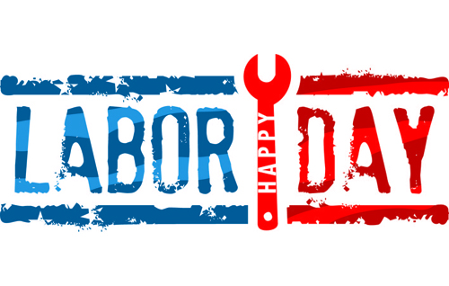 | September 4  Popcorn Chicken  W/ Roll  Or  Hamburger  Baby Carrots  Broccoli  Choice of Fruit / Milk | September 5  Cheeseburger Sliders  Or  Chicken Cheesesteak  Baked Beans  Celery w/ Dip  Choice of Fruit / Milk | September 6  Spaghetti and Meatballs  W/G Roll  Or  Shrimp Poppers w/ Roll  Grape Tomatoes  Romaine Salad  Choice of Fruit / Milk | September 7  Pepperoni Pizza  Or  Meatball Sub  Peas  Baby Carrots  Choice of Fruit / Milk | Offer verses serve -  Students must take  3 of 5 items to count as a lunch & one must be a fruit or vegetable.
 | September 10  Chicken Tenders  W/ Roll  Or  Buffalo Chicken Pizza  Peas  Grape Tomatoes  Choice of Fruit / Milk | September 11  Pulled Pork Sandwich  Or  Cheeseburger  W/G Roll  French Fries  Baked Beans  Choice of Fruit / Milk | September 12  Chicken Patty  Sandwich  Or  Turkey Club Wrap  Steamed Broccoli  Baby Carrots  Choice of Fruit / Milk | September 13  General Tso’s Chicken  w/ W/G roll  Or  Hot Dog  Oriental Vegs/ Rice  Egg Roll / Fortune Cookie  Choice of Fruit / Milk | September 14  BBQ Rib Sandwich  Or  Tukey & Cheese on Pretzel Roll  Green Beans  Baby Carrots  Choice of Fruit / Milk | Daily Entrée options include:  Chef Or Chicken Salad with whole grain roll Or Whole grain P B & J sandwich  Fruit, Vegetable & milk are included
All Meals are  served with 1% milk, fat free chocolate, fat free vanilla, fat free strawberry and skim | September 17  Stuffed Shells  Breadsticks  Or  Cowboy Burger  Tossed Salad  Grape Tomatoes  Choice of Fruit / Milk | September 18  Hot Turkey Sandwich  Or  Chicken Patty Sandwich  Mashed Potatoes  Celery w/ dip  Choice of Fruit / Milk | September 19  Cheesesteak  Or  Spicy Chicken Patty  Baked beans  Grape Tomatoes  Choice of Fruit / Milk | September 20  Chicken Sticks  Breadstick  Or  Meatball Sub  Tossed Salad  Broccoli  Choice of Fruit / Milk | September 21  Pizza  Or  Chicken Nuggets  W/ Roll  Peas  Baby Carrots  Choice of Fruit / Milk
No breakfast on two hour delays | September 24  Tomato Soup  Grilled Cheese Sandwich  Or  Ham & Cheese Hoagie  Corn  Tossed Salad  Choice of Fruit / Milk | September 25  Walking Taco  Or  Fish Nuggets  W/G Roll  Refried Beans  Baby Carrots  Choice of Fruit / Milk | September 26  Cheeseburger  Or  Ham & Cheese  Pretzel bun  Cheesy Broccoli  Grape Tomatoes  Choice of Fruit / Milk | September 27  Mashed Potato Bowl  W/ Roll  Or  Calzone  Peas  Baby Carrots  Choice of Fruit / Milk | September 28  Chicken Patty Sandwich  Or  Fish Sandwich  Grape Tomatoes  Green Beans  Choice of Fruit / Milk | Middle/HS Lunch-  $ 2.75  Milk - .50  Reduced - .40
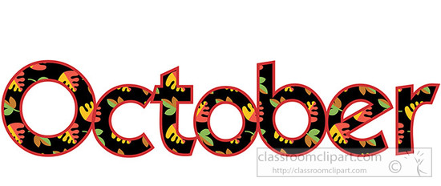 | October 1  Nacho Grande  Or  Pulled Pork Sandwich  Broccoli  Grape Tomatoes  Choice of Fruit / Milk | October 2  Popcorn Chicken  W/ Roll  Or  Hamburger  Baby Carrots  Corn  Choice of Fruit / Milk | October 3  Cheeseburger Sliders  Or  Chicken Cheesesteak  Baked Beans  Celery w/ dip  Choice of Fruit / Milk | October 4  Spaghetti and Meatballs  W/G Roll  Or  Shrimp Poppers w/ Roll  Peas  Romaine Salad  Choice of Fruit / Milk | October 5  Pepperoni Pizza  Or  Meatball Sub  Green Beans  Baby Carrots  Choice of Fruit / Milk | Menu subject to change

