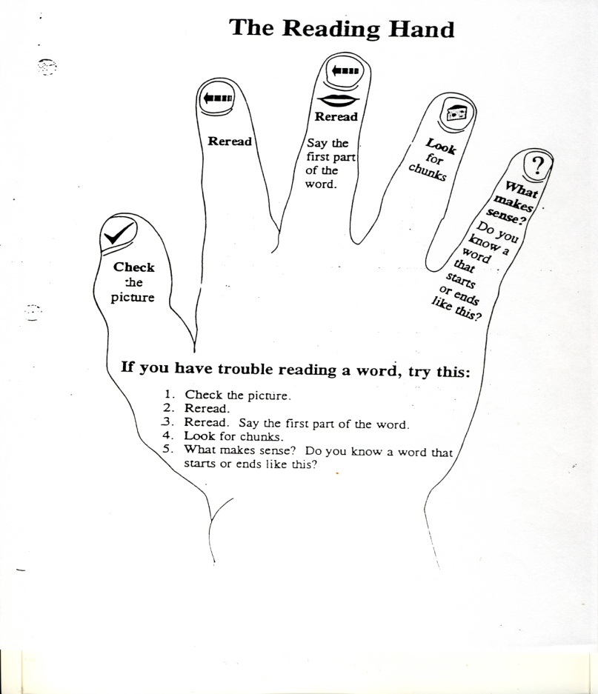

The Reading Hand is an example of how students can remember the reading strategies they can use to decode words. Students should use these strategies before an adult tells them the unknown word.