Fannett-Metal School District - High School / Middle School April 2018

Fannett-Metal is an equal opportunity provider

SUNDAY | MONDAY | TUESDAY | WEDNESDAY | THURSDAY | FRIDAY | SATURDAY
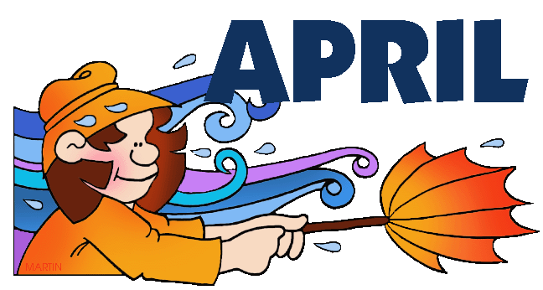 | April 2  No School | April 3  Chicken & Waffles  w/ Gravy  Or  Italian Hoagie  Baked Beans  Grape Tomatoes  Choice of Fruit / Milk | April 4  Lasagna or Stuffed  Shells – Garlic Bread  Or  Hoagie Variety  Romaine Salad  Baby Carrots  Choice Fruit / Milk | April 5  Chicken Alfredo  W/ Roll  Or  Fish Sandwich  Steamed Carrots  Cucumbers w/ Dip  Choice of Fruit / Milk | April 6  Chicken Patty Sliders  Or  Taco Pizza  Broccoli w/ Cheese  Celery  Choice of Fruit / Milk | Offer verses serve -  Students must take  3 of 5 items to count as a lunch & one must be a fruit or vegetable.
All Meals are  served with 1% milk, fat free chocolate, fat free vanilla, fat free strawberry and skim | April 9  Turkey w/ Gravy  Or  Cowboy Burger  Mashed Potatoes  Corn / Stuffing  Grape Tomatoes  Choice of Fruit / Milk | April 10  General Tso’s Chicken  W/G roll  Or  Grilled Ham & Cheese  Steamed Carrots  Rice / Fortune Cookie  Choice of Fruit / Milk | April 11  Baked Spaghetti  Garlic Bread  Or  Turkey & Cheese  Pretzel Bun  Broccoli / Salad  Choice of Fruit / Milk | April 12  National Grilled Cheese Day  Tomato Soup  Grilled Cheese Sandwich  Or  Pizza  Navy Beans  Baby Carrots  Choice of Fruit / Milk  led cheese Day | April 13  Breakfast for Lunch  Breakfast Bowl  Or  Chicken Cheesesteak  Hash Brown  Peas  Choice of Fruit/Milk | Daily Entrée options include:  Chef Salad with whole grain roll Or Whole grain P B & J sandwich  Fruit, Vegetable & milk are included
 | April 16  Beef & Gravy  Over Noodles  Or  Hot Dog  Grape Tomatoes  Corn  Choice of Fruit/Milk | April 17  Cheeseburger Sub  OR  Chicken Fajita  Broccoli w/ Cheese  Romaine Salad  Choice of Fruit / Milk | April 18  Roast Chicken  w/ Roll  Or  Turkey Club Wrap  Steamed Carrots  Scalloped Potatoes  Choice of Fruit / Milk | April 19  Broccoli & Cheese Soup  Cheesesteak  Or  Pulled Pork Sandwich  Baked Beans  Baby Carrots  Choice of Fruit / Milk | April 20  Cheese or White Pizza  Or  Sloppy Joe Sandwich  Peas  Tatar Tots  Choice of Fruit / Milk | Breakfast Bowl – Diced Potatoes, Egg, Cheese, Sausage Crumbles with a biscuit
 | April 23  Walking Taco  Or  Fish Nuggets  w/ Roll  Refried Beans  Baby Carrots  Choice of Fruit / Milk | April 24  Pork & Sauerkraut  W/G Roll  Or  Hamburger  Mashed Potato  Corn  Choice of Fruit / Milk | April 25  Meat Lover’s Pizza  Or  Stuffed Shells w/ Roll  Steamed Carrots  Romaine Salad  Choice of Fruit / Milk | April 26  Spaghetti & Meatballs  Breadstick  Or  Italian Hoagie  Grape Tomatoes  Peas  Choice of Fruit / Milk | April 27  Nacho Grande  Or  Meatball Sub  Celery  Broccoli w/ Cheese  Choice of Fruit / Milk | Middle/HS Lunch-  $ 2.70  Milk - .50  Reduced - .40
No breakfast on two hour delays | April 30  Mashed Potato Bowl  W/G Roll  Or  Fish Sandwich  Steamed Carrots  Grape Tomatoes  Choice of Fruit / Milk | May 1  Baked Doritos Casserole  W/ Roll  Or  Turkey & Cheese Hoagie  Peas  Baby Carrots  Choice of Fruit / Milk | May 2  Chicken Noodle Soup  Popcorn Chicken w/ Roll  Or  BBQ Rib Sandwich  Romaine Salad  Baked Beans  Choice of Fruit / Milk | May 3  Macaroni & Cheese  W/ Roll  Or  Spicy Chicken Patty  Cucumber W/ Dip  Steamed Tomatoes  Choice of Fruit / Milk | May 4  Chicken Patty Sandwich  Or  Chef’s Choice  Broccoli w/ Cheese  Celery  Choice of Fruit / Milk
Menu Subject to Change

