Fannett-Metal School District - Elementary School April 2018

Fannett-Metal is an equal opportunity provider

SUNDAY | MONDAY | TUESDAY | WEDNESDAY | THURSDAY | FRIDAY | SATURDAY
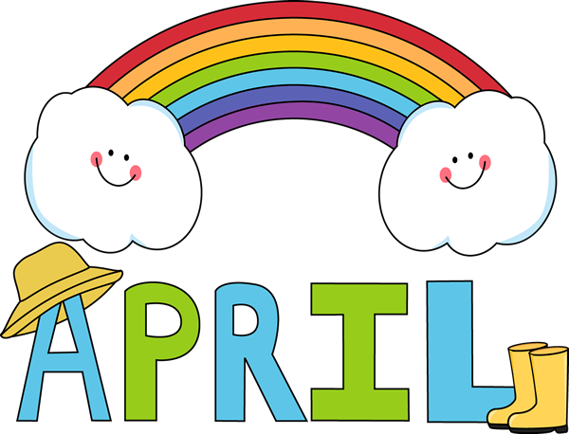 | April 2  No School | April 3  Chicken Sticks  W/G Roll  Or  Hamburger  Baked Beans  Baby Carrots  Choice of Fruit / Milk | April 4  Chicken Alfredo  Bread Stick  Or  Corn Dog  Peas  Romaine Salad  Choice of Fruit / Milk | April 5  Baked Doritos Casserole  W/ Roll  Or  Turkey & Cheese Hoagie  Steamed Carrots  Grape Tomatoes  Choice of Fruit / Milk | ^{April 6}  Pepperoni Pizza  Or  Chicken Patty Sandwich  Celery  Broccoli W/ Cheese  Choice of Fruit / Milk | Offer verses serve -  Students must take  3 of 5 items to count as a lunch & one must be a fruit or vegetable.
All Meals are  served with 1% milk, fat free chocolate, fat free vanilla, fat free strawberry and skim | April 9  BBQ Rib Sandwich  Or  Cheesesteak  Baked Beans  Corn  Choice of Fruit / Milk | April 10  Italian Pasta W/ Sauce  Breadstick  Or  Grilled Ham & Cheese  Romaine Salad  Peas  Choice of Fruit / Milk | April 11  Hamburger Macaroni  W/G Roll  Or  Hot Dog  Steamed Carrots  Grape Tomatoes  Choice of Fruit / Milk | April 12  National Grilled Cheese Day  Tomato Soup  Grilled Cheese  Or  Sloppy Joe Sandwich  Broccoli  Romaine Salad  Choice of Fruit / Milk | April 13  Taco Pizza  Or  Fish Nuggets W/ Roll  Grape Tomatoes  Corn  Choice of Fruit / Milk | Pre-K Alternative  April 4th - Pizza  April 11th – Chicken Nuggets w/ Roll
 | April 16  Chicken & Waffles  W / Gravy  Or  Cheeseburger  Baby Carrots  Green Beans  Choice of Fruit/Milk | April 17  Beef & Noodles  W/ gravy & Roll  Or  Soft Shell Taco  Sliced Tomatoes  Baked Beans  Choice of Fruit / Milk | April 18  Walking Taco  Or  Turkey & Cheese  Pretzel Roll  Steamed Carrots  Grape Tomatoes  Choice of Fruit / Milk | April 19  Spaghetti & Meatballs  Breadstick  Or  Chicken Sandwich  Broccoli  Romaine Salad  Choice of Fruit / Milk | April 20  Pepperoni Pizza  Or  Meatball Sub  Smiley Fries  Baby Carrots  Choice of Fruit / Milk
 | April 23  Mashed Potato Bowl  W/G Roll  Or  Hamburger  Peas  Celery  Choice of Fruit / Milk | April 24  Sweet & Sour Chicken  Breadstick  Or  Turkey & Cheese Wrap  Broccoli / Rice  Baby Carrots  Choice of Fruit / Milk | April 25  Popcorn Chicken  W/ Roll  Or  Chef Salad W/ Roll  Baked Beans  Sliced Tomatoes  Choice of Fruit / Milk | April 26  Macaroni & Cheese  W/G Roll  Or  Chicken Cheesesteak  Romaine Salad  Steamed Carrots  Choice of Fruit / Milk | April 27  French Bread Pizza  Or  Fish Nuggets  Roll  Sweet Potato Fries  Broccoli W/ Cheese  Choice of Fruit/Milk | Elementary Lunch-  $ 2.55  Milk - .50  Reduced - .40
No breakfast on two hour delays | April 30  Soft Shell Taco  Or  Meatball Sub  Grape Tomato  Peas  Choice of Fruit / Milk | May 1  Chicken Sticks  W/G Roll  Or  Cheeseburger  Baked Beans  Baby Carrots  Choice of Fruit / Milk | May 2  Baked Doritos Casserole  W/ Roll  Or  Turkey & Cheese Hoagie  Steamed Carrots  Romaine Salad  Choice of Fruit / Milk | May 3  Breakfast for Lunch  Pancakes & Sausage  Or  Grilled Ham & Cheese  Hash Brown  Grape Tomatoes  Choice of Fruit / Milk | ^{May 4}  Pepperoni Pizza  Or  Fish Sandwich  Celery  Broccoli W/ Cheese  Choice of Fruit / Milk | Menu Subject to Change

