FANNETT-METAL SCHOOL DISTRICT – Elementary School – March 2018

Fannett-Metal School District is an equal opportunity provider
SUNDAY | MONDAY | TUESDAY | WEDNESDAY | THURSDAY | FRIDAY | SATURDAY
 |  |  |  | March 1  Breakfast Pizza  Or  Cereal  Whole grain bread  Fruit / Vegetable  Milk / Juice | March 2  Cinnamon Bun  Or  Cereal Bar  Yogurt  Fruit / Vegetable  Milk / Juice | Menu Subject to Change
 | March 5  French Toast Sticks  Or  Cereal  Whole grain bread  Fruit / Vegetable  Milk / Juice | March 6  Pancakes on a stick  Or  Cereal Bar  Yogurt  Fruit / Vegetable  Milk / Juice | March 7  Pancakes & Sausage Patty  Or  Cereal  Whole Grain Bread  Fruit / Vegetable  Milk / Juice | March 8  Breakfast Pizza  Or  Cereal  Whole grain bread  Fruit / Vegetable  Milk / Juice | March 9  Cinnamon Bun  Or  Cereal Bar  Yogurt  Fruit / Vegetable  Milk / Juice
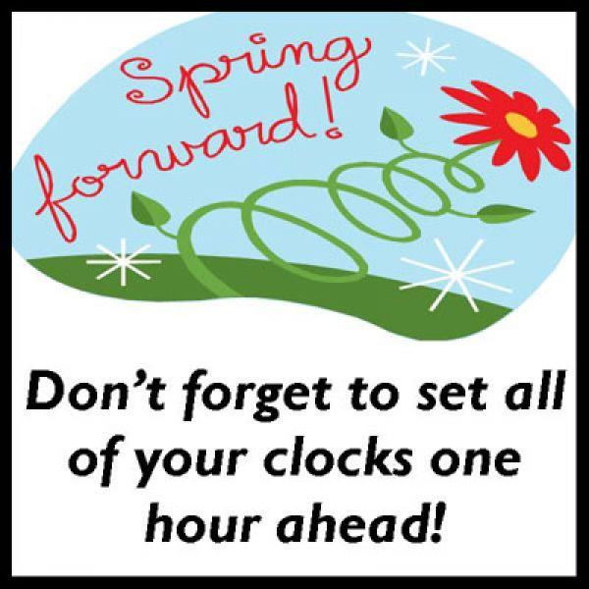 | March 12  French Toast Sticks  Or  Cereal  Whole grain bread  Fruit / Vegetable  Milk / Juice | March 13  Pancakes on a stick  Or  Cereal Bar  Yogurt  Fruit / Vegetable  Milk / Juice | March 14  Pancakes & Sausage Patty  Or  Cereal  Whole Grain Bread  Fruit / Vegetable  Milk / Juice | March 15  Breakfast Pizza  Or  Cereal  Whole grain bread  Fruit / Vegetable  Milk / Juice | March 16  Cinnamon Bun  Or  Cereal Bar  Yogurt  Fruit / Vegetable  Milk / Juice
No Breakfast on two Hour Delays | March 19  French Toast Sticks  Or  Cereal  Whole grain bread  Fruit / Vegetable  Milk / Juice | March 20  Pancakes on a stick  Or  Cereal Bar  Yogurt  Fruit / Vegetable  Milk / Juice | March 21  Pancakes & Sausage Patty  Or  Cereal  Whole Grain Bread  Fruit / Vegetable  Milk / Juice | March 22  Breakfast Pizza  Or  Cereal  Whole grain bread  Fruit / Vegetable  Milk / Juice | March 23  Cinnamon Bun  Or  Cereal Bar  Yogurt  Fruit / Vegetable  Milk / Juice | Elementary & MS/HS  Breakfast-$ 1.50  Milk -$.50  Reduced -$.25
All Meals are  served with 1% milk, fat free chocolate, fat free vanilla, fat free strawberry and skim | March 26  French Toast Sticks  Or  Cereal  Whole grain bread  Fruit / Vegetable  Milk / Juice | March 27  Pancakes on a stick  Or  Cereal Bar  Yogurt  Fruit / Vegetable  Milk / Juice | March 28  Pancakes & Sausage Patty  Or  Cereal  Whole Grain Bread  Fruit / Vegetable  Milk / Juice | March 29  No School | March 30  No School
To manage accounts: www.myschoolaccount.com No breakfast on 2 hour delays *Menu Subject to Change

