FANNETT-METAL SCHOOL DISTRICT – Elementary School – February 2018

Fannett-Metal School District is an equal opportunity provider
SUNDAY | MONDAY | TUESDAY | WEDNESDAY | THURSDAY | FRIDAY | SATURDAY
 |  |  |  | February 1  Breakfast Pizza  Or  Cereal  Whole grain bread  Fruit / Vegetable  Milk / Juice | February 2  Cinnamon Bun  Or  Cereal Bar  Yogurt  Fruit / Vegetable  Milk / Juice
 | February 5  French Toast Sticks  Or  Cereal  Whole grain bread  Fruit / Vegetable  Milk / Juice | February 6  Pancakes on a stick  Or  Cereal Bar  Yogurt  Fruit / Vegetable  Milk / Juice | February 7  Pancakes & Sausage Patty  Or  Cereal  Whole Grain Bread  Fruit / Vegetable  Milk / Juice | February 8  Breakfast Pizza  Or  Cereal  Whole grain bread  Fruit / Vegetable  Milk / Juice | February 9  Cinnamon Bun  Or  Cereal Bar  Yogurt  Fruit / Vegetable  Milk / Juice
All Meals are  served with 1% milk, fat free chocolate, fat free vanilla, fat free strawberry and skim | February 12  French Toast Sticks  Or  Cereal  Whole grain bread  Fruit / Vegetable  Milk / Juice | February 13  Pancakes on a stick  Or  Cereal Bar  Yogurt  Fruit / Vegetable  Milk / Juice | February 14  Pancakes & Sausage Patty  Or  Cereal  Whole Grain Bread  Fruit / Vegetable  Milk / Juice | February 15  Breakfast Pizza  Or  Cereal  Whole grain bread  Fruit / Vegetable  Milk / Juice | February 16  No School
 | February 19  No School | February 20  Pancakes on a stick  Or  Cereal Bar  Yogurt  Fruit / Vegetable  Milk / Juice | February 21  Pancakes & Sausage Patty  Or  Cereal  Whole Grain Bread  Fruit / Vegetable  Milk / Juice | February 22  Breakfast Pizza  Or  Cereal  Whole grain bread  Fruit / Vegetable  Milk / Juice | February 23  Cinnamon Bun  Or  Cereal Bar  Yogurt  Fruit / Vegetable  Milk / Juice | Elementary & MS/HS  Breakfast-$ 1.50  Milk -$.50  Reduced -$.25
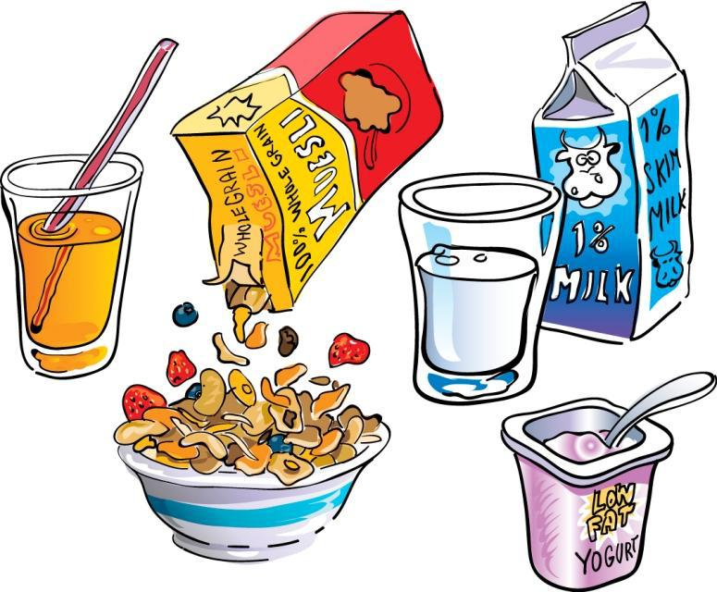 | February 26  French Toast Sticks  Or  Cereal  Whole grain bread  Fruit / Vegetable  Milk / Juice | February 27  Pancakes on a stick  Or  Cereal Bar  Yogurt  Fruit / Vegetable  Milk / Juice | February 28  Pancakes & Sausage Patty  Or  Cereal  Whole Grain Bread  Fruit / Vegetable  Milk / Juice | March 1  Breakfast Pizza  Or  Cereal  Whole grain bread  Fruit / Vegetable  Milk / Juice | March 2  Cinnamon Bun  Or  Cereal Bar  Yogurt  Fruit / Vegetable  Milk / Juice
To manage accounts: www.myschoolaccount.com No breakfast on 2 hour delays *Menu Subject to Change

