Fannett-Metal School District - High School / Middle School November 2017

Fannett-Metal is an equal opportunity provider

SUNDAY | MONDAY | TUESDAY | WEDNESDAY | THURSDAY | FRIDAY | SATURDAY
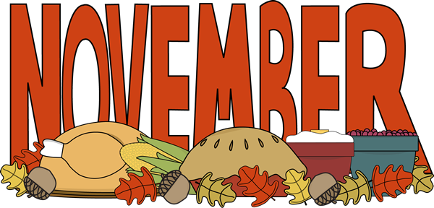 |  |  | November 1  Pulled Pork Sandwich  Or  Chicken Patty Sandwich  Broccoli  Baby Carrots  Choice of Fruit / Milk | November 2  Chicken Alfredo  Breadstick  Or  Calzone  Romaine Salad  Peas  Choice of Fruit / Milk | November 3  Chicken Patty Sliders  Or  Turkey Club Wrap  Corn  Celery  Choice of Fruit / Milk | Offer verses serve -  Students must take  3 of 5 items to count as a lunch & one must be a fruit or vegetable.
 | November 6  Lasagna  Breadstick  Or  Hamburger  Romaine Salad  Peas  Choice of Fruit / Milk | November 7  Walking Taco  Or  Fish Nuggets  W/G Roll  Refried Beans  Baby Carrots  Choice of Fruit / Milk | November 8  Cheeseburger  Or  Chicken Cheese steak  Steamed Carrots  Celery  Choice of Fruit / Milk | November 9  Spaghetti and Meatballs  W/G Roll  Or  Cheese Pizza  Grape Tomatoes  Broccoli  Choice of Fruit / Milk | November 10  No School | Daily Entrée options include:  Chef or TacoSalad with whole grain roll Or Whole grain P B & J sandwich  Fruit, Vegetable & milk are included
All Meals are  served with 1% milk, fat free chocolate, fat free vanilla, fat free strawberry and skim | November 13  Mashed Potato Bowl  W/G Roll  Or  Chicken Fajitas  Peas  Celery  Choice of Fruit / Milk | November 14  Chicken Parmesan  Over Penne Pasta  Or  Cowboy burger  Romaine Salad  Steamed Carrots  Choice of Fruit / Milk | November 15  Stuffed Shells W/ Roll  Or  Baked Chicken Sandwich  Baby Carrots  Green Beans  Choice of Fruit / Milk | November 16  Roast Turkey W/ Gravy  Roll  Or  Fish Sandwich  Mashed Potatoes  Corn / Stuffing  Choice of Fruit / Milk | November 17  Toasted Italian Hoagie  Or  Stromboli  Baked Beans  Grape Tomatoes  Choice of Fruit / Milk
 | November 20  Rib B Q Sandwich  Or  Ham & Cheese Pretzel Roll  Romaine Salad  Peas  Choice of Fruit / Milk | November 21  General Tso’s Chicken  w/ W/G roll  Or  Hamburger  Oriental Vegs  Rice  Choice of Fruit / Milk | November 22  Cheesesteak  Or  Spicy Chicken Patty  Baked Beans  Grape Tomatoes  Choice of Fruit / Milk | November 23  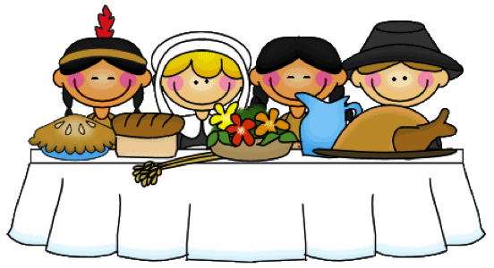 | November 24  No School | Middle/HS Lunch-  $ 2.70  Milk - .50  Reduced - .40
No breakfast on two hour delays | November 27  No School | November 28  No School | November 29  Pulled Pork Sandwich  Or  Chicken Patty Sandwich  Broccoli  Baby Carrots  Choice of Fruit / Milk | November 30  Chicken Alfredo  Breadstick  Or  Calzone  Romaine Salad  Peas  Choice of Fruit / Milk | December 1  Chicken Patty Sliders  Or  Turkey Club Wrap  Corn  Celery  Choice of Fruit / Milk | Menu subject to change

