Fannett-Metal School District - Elementary School November 2017

Fannett-Metal is an equal opportunity provider

SUNDAY | MONDAY | TUESDAY | WEDNESDAY | THURSDAY | FRIDAY | SATURDAY
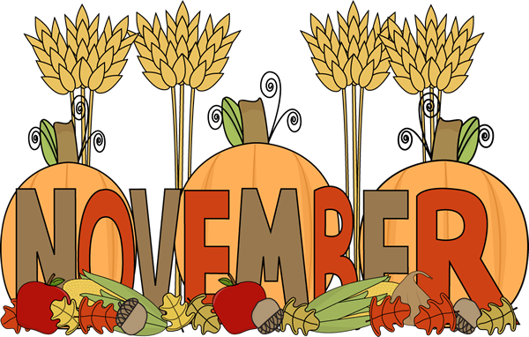 |  |  | November 1  Chicken Stir Fry  Lo Mein Noodles  Or  Fish Sandwich  Broccoli / Fortune Cookie  Baby Carrots  Choice of Fruit / Milk | November 2  Hot Turkey Sandwich  W/ Gravy  Or  Calzone  Romaine Salad  Mashed Potatoes  Choice of Fruit / Milk | ^{November 3}  Pepperoni Pizza  Or  Fish Nuggets w/ Roll  Peas  Cucumbers  Choice of Fruit / Milk | Offer verses serve -  Students must take  3 of 5 items to count as a lunch & one must be a fruit or vegetable.
 | November 6  Lasagna  Breadstick  Or  Pizza Burger  Green Beans  Tossed Salad  Choice of Fruit / Milk | November 7  Soft Shell Taco  Or  Turkey & Cheese Wrap  Refried Beans  Grape Tomatoes  Choice of Fruit / Milk | November 8  Roast Turkey w/ Gravy  W/G Roll  Or  Hot Dog  Mashed Potatoes  Baby Carrots  Choice of Fruit / Milk | November 9  Popcorn Chicken W/ Roll  Or  Chef Salad W/ Roll  Steamed Broccoli  Red Peppers  Choice of Fruit / Milk | November 10  No School
All Meals are  served with 1% milk, fat free chocolate, fat free vanilla, fat free strawberry and skim | November 13  Stuffed Shells  W/G Roll  Or  Chicken Cheese Steak  Broccoli  Red Peppers w/ dip  Choice of Fruit / Milk | November 14  Chicken Sticks  W/G Roll  Or  Sloppy Joe Sandwich  Baked Beans  Celery  Choice of Fruit / Milk | November 15  Chicken Alfredo  Bread Stick  Or  Turkey & Cheese  Pretzel Roll  Romaine Salad  Sliced cucumbers  Choice of Fruit / Milk | November 16  Cheese Steak  Or  Meatball Sub  Peas  Baby Carrots  Choice of Fruit / Milk | November 17  Chicken Patty  Or  Cheese Pizza  Steamed Carrots  Corn  Choice of Fruit / Milk | Pre-K Alternative  November 8th – Chicken Patty Sandwich
 | November 20  Tomato Soup  Grilled Cheese Sandwich  Or  Baked Chicken Sandwich  Peas/ Grape Tomatoes  Choice of Fruit / Milk | November 21  Chicken Tenders  W/ Roll  Or  Hamburger  Romaine Salad  Corn  Choice of Fruit / Milk | November 22  Walking Taco  Or  Chicken Patty  Baby Carrots  Green Beans  Choice of Fruit / Milk | November 23  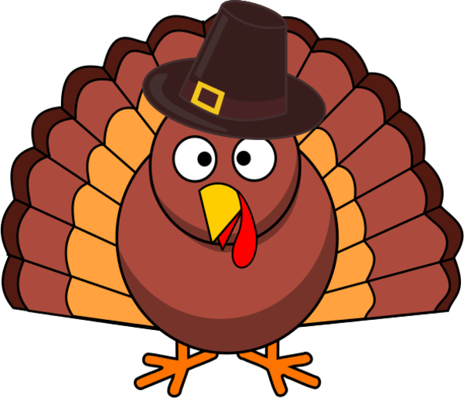 | November 24  No School | Middle/HS Lunch-  $ 2.55  Milk - .50  Reduced - .40
No breakfast on two hour delays | November 27  No School | November 28  No School | November 29  Spaghetti and Meatballs  Breadstick  Or  Baked Chicken Sandwich  Broccoli/ Baby Carrots  Choice of Fruit / Milk | November 30  Chicken Nuggets w/ Roll  Or  Meatball Sub.  Romaine Salad  Corn  Choice of Fruit / Milk | ^{December 1}  Pepperoni Pizza  Or  Fish Nuggets w/ Roll  Peas  Red Peppers w/ dip  Choice of Fruit / Milk | Menu subject to change

