Fannett-Metal School District – Middle – High School November 2017
USDA Nondiscrimination Statement and Complaint Procedure
The U.S Department of Agriculture prohibits discrimination against its customers, employees, and applicants for employment on the bases of race, color, national origin, age, disability, sex, gender identity, religion, reprisal, and where applicable, political beliefs, marital status, familial or parental status, sexual orientation, or if all or part of an individual's income is derived from any public assistance program, or protected genetic information in employment or in any program or activity conducted or funded by the Department. (Not all prohibited bases will apply to all programs and/or employment activities.)
If you wish to file a Civil Rights program complaint of discrimination, complete the USDA Program Discrimination Complaint Form, found online at http://www.ascr.usda.gov/complaint_filing_cust.html, or at any USDA office, or call (866) 632-9992 to request the form. You may also write a letter containing all of the information requested in the form. Send your completed complaint form or letter to us by mail at U.S. Department of Agriculture, Director, Office of Adjudication, 1400 Independence Avenue, S.W., Washington, D.C. 20250-9410, by fax (202) 690-7442 or email at program.intake@usda.gov .
Individuals who are deaf, hard of hearing or have speech disabilities may contact USDA through the Federal Relay Service at (800) 877-8339; or (800) 845-6136 (Spanish
Fannett-Metal is an equal opportunity provider

SUNDAY | MONDAY | TUESDAY | WEDNESDAY | THURSDAY | FRIDAY | SATURDAY
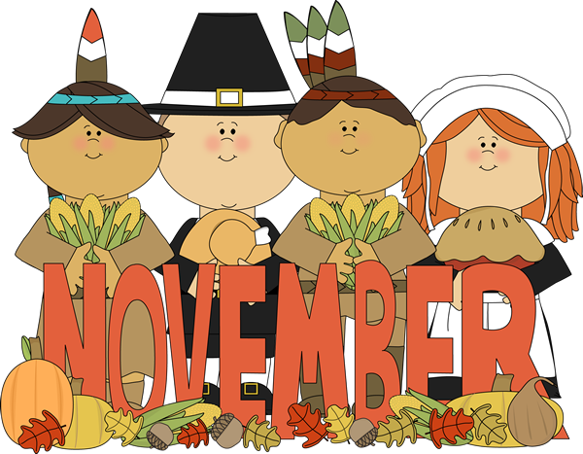 |  |  | November 1  Pancakes &  Sausage Links  Or  Cereal  Whole Grain Bread  Fruit / Vegetable  Milk / Juice | November 2  Breakfast Pizza  Or  Cereal  Whole Grain Bread  Fruit / Vegetable  Milk / Juice | November 3  Cinnamon Bun  Or  Cereal  Whole Grain Bread  Fruit / Vegetable  Milk / Juice | Offer verses serve -  Students must take  3 of 5 items to count as a lunch & one must be a fruit or vegetable.
 | November 6  French Toast Sticks  Or  Cereal  Whole Grain Bread  Fruit / Vegetable  Milk / Juice | November 7  Sausage, Egg and Cheese Biscuit  Or  Cereal  Whole Grain Bread  Fruit / Vegetable  Milk / Juice | November 8  Pancakes &  Sausage Links  Or  Cereal  Whole Grain Bread  Fruit / Vegetable  Milk / Juice | November 9  Breakfast Pizza  Or  Cereal  Whole Grain Bread  Fruit / Vegetable  Milk / Juice | November 10  No School | Menu subject to change
All Meals are  served with 1% milk, fat free chocolate, fat free vanilla, fat free strawberry and skim | November 13  French Toast Sticks  Or  Cereal  Whole Grain Bread  Fruit / Vegetable  Milk / Juice | November 14  Sausage, Egg and Cheese Biscuit  Or  Cereal  Whole Grain Bread  Fruit / Vegetable  Milk / Juice | November 15  Pancakes &  Sausage Links  Or  Cereal  Whole Grain Bread  Fruit / Vegetable  Milk / Juice | November 16  Breakfast Pizza  Or  Cereal  Whole Grain Bread  Fruit / Vegetable  Milk / Juice | November 17  Cinnamon Bun  Or  Cereal  Whole Grain Bread  Fruit / Vegetable  Milk / Juice
 | November 20  French Toast Sticks  Or  Cereal  Whole Grain Bread  Fruit / Vegetable  Milk / Juice | November 21  Sausage, Egg and Cheese Biscuit  Or  Cereal  Whole Grain Bread  Fruit / Vegetable  Milk / Juice | November 22  Pancakes &  Sausage Links  Or  Cereal  Whole Grain Bread  Fruit / Vegetable  Milk / Juice | November 23  No School | November 24  No School | High School Breakfast  $ 1.50  Milk - .50  Reduced - .40
No breakfast on two hour delays | November 27 | November 28 | November 29  Pancakes &  Sausage Links  Or  Cereal  Whole Grain Bread  Fruit / Vegetable  Milk / Juice | November 30  Breakfast Pizza  Or  Cereal  Whole Grain Bread  Fruit / Vegetable  Milk / Juice | December 1  Cinnamon Bun  Or  Cereal  Whole Grain Bread  Fruit / Vegetable  Milk / Juice

