FANNETT-METAL SCHOOL DISTRICT – Elementary School – November 2017

Fannett-Metal School District is an equal opportunity provider
SUNDAY | MONDAY | TUESDAY | WEDNESDAY | THURSDAY | FRIDAY | SATURDAY
 |  |  | November 1  Pancakes & Sausage Patty  Or  Cereal  Whole Grain Bread  Fruit / Vegetable  Milk / Juice | November 2  Breakfast Pizza  Or  Cereal  Whole grain bread  Fruit / Vegetable  Milk / Juice | November 3  Cinnamon Bun  Or  Cereal Bar  Yogurt  Fruit / Vegetable  Milk / Juice | 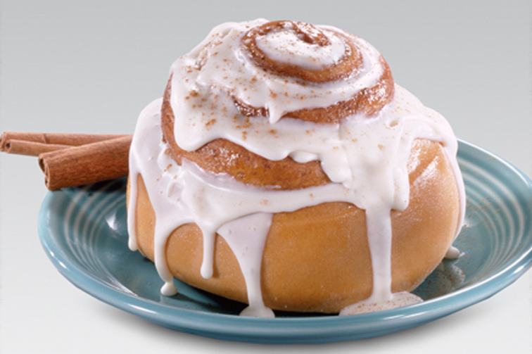
 | November 6  French Toast Sticks  Or  Cereal  Whole grain bread  Fruit / Vegetable  Milk / Juice | November 7  Pancakes on a stick  Or  Cereal Bar  Yogurt  Fruit / Vegetable  Milk / Juice | November 8  Pancakes & Sausage Patty  Or  Cereal  Whole Grain Bread  Fruit / Vegetable  Milk / Juice | November 9  Breakfast Pizza  Or  Cereal  Whole grain bread  Fruit / Vegetable  Milk / Juice | November 10  No School
All Meals are  served with 1% milk, fat free chocolate, fat free vanilla, fat free strawberry and skim | November 13  French Toast Sticks  Or  Cereal  Whole grain bread  Fruit / Vegetable  Milk / Juice | November 14  Pancakes on a stick  Or  Cereal Bar  Yogurt  Fruit / Vegetable  Milk / Juice | November 15  Pancakes & Sausage Patty  Or  Cereal  Whole Grain Bread  Fruit / Vegetable  Milk / Juice | November 16  Breakfast Pizza  Or  Cereal  Whole grain bread  Fruit / Vegetable  Milk / Juice | November 17  Cinnamon Bun  Or  Cereal Bar  Yogurt  Fruit / Vegetable  Milk / Juice
 | November 20  French Toast Sticks  Or  Cereal  Whole grain bread  Fruit / Vegetable  Milk / Juice | November 21  Pancakes on a stick  Or  Cereal Bar  Yogurt  Fruit / Vegetable  Milk / Juice | November 22  Pancakes & Sausage Patty  Or  Cereal  Whole Grain Bread  Fruit / Vegetable  Milk / Juice | November 23  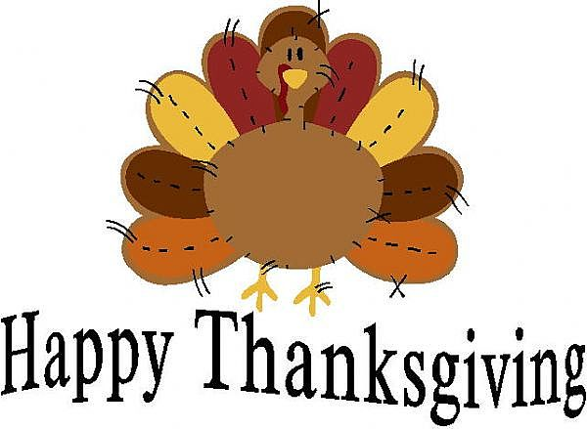 | November 24  No School | Elementary & MS/HS  Breakfast-$ 1.50  Milk -$.50  Reduced -$.25
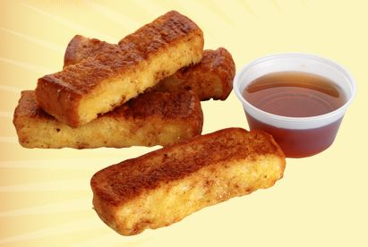 | November 27  No School | November 28  No School | November 29  Pancakes & Sausage Patty  Or  Cereal  Whole Grain Bread  Fruit / Vegetable  Milk / Juice | November 30  Breakfast Pizza  Or  Cereal  Whole grain bread  Fruit / Vegetable  Milk / Juice | December 1  Cinnamon Bun  Or  Cereal Bar  Yogurt  Fruit / Vegetable  Milk / Juice
To manage accounts: www.myschoolaccount.com No breakfast on 2 hour delays *Menu Subject to Change

