Fannett-Metal School District – Elementary School August 2017
USDA Nondiscrimination Statement and Complaint Procedure
The U.S Department of Agriculture prohibits discrimination against its customers, employees, and applicants for employment on the bases of race, color, national origin, age, disability, sex, gender identity, religion, reprisal, and where applicable, political beliefs, marital status, familial or parental status, sexual orientation, or if all or part of an individual's income is derived from any public assistance program, or protected genetic information in employment or in any program or activity conducted or funded by the Department. (Not all prohibited bases will apply to all programs and/or employment activities.)
If you wish to file a Civil Rights program complaint of discrimination, complete the USDA Program Discrimination Complaint Form, found online at http://www.ascr.usda.gov/complaint_filing_cust.html, or at any USDA office, or call (866) 632-9992 to request the form. You may also write a letter containing all of the information requested in the form. Send your completed complaint form or letter to us by mail at U.S. Department of Agriculture, Director, Office of Adjudication, 1400 Independence Avenue, S.W., Washington, D.C. 20250-9410, by fax (202) 690-7442 or email at program.intake@usda.gov .
Individuals who are deaf, hard of hearing or have speech disabilities may contact USDA through the Federal Relay Service at (800) 877-8339; or (800) 845-6136 (Spanish
Fannett-Metal is an equal opportunity provider

SUNDAY | MONDAY | TUESDAY | WEDNESDAY | THURSDAY | FRIDAY | SATURDAY
 |  | August 1 | August 2 | August 3 | August 4 | Offer verses serve -  Students must take  3 of 5 items to count as a lunch & one must be a fruit or vegetable.
 | August 7 | August 8 | August 9  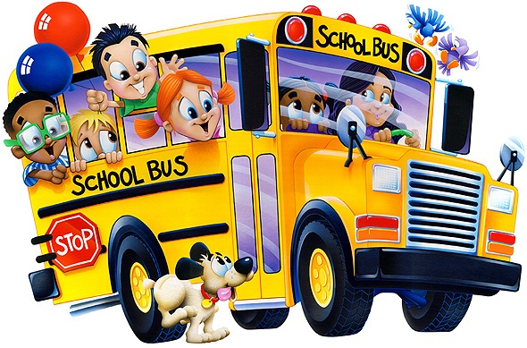 | August 10 | August 11 | 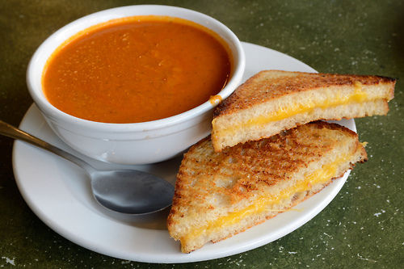
All Meals are  served with 1% milk, fat free chocolate, fat free vanilla, fat free strawberry and skim | August 14 | August 15 | August 16 | August 17 | August 18 | Pre-K Alternate Meal  August 30th – Chicken Nuggets w/ Roll
 | August 21  PRE-K  Breakfast  Cereal – Fruit – Milk  Lunch  Peanut Butter & Jelly  Corn  Choice of Fruit / Milk | August 22  PRE-K  Breakfast  Cereal – Fruit – Milk  Lunch  Hamburger  Peas  Choice of Fruit / Milk | August 23  Calzone  Or  Chicken Patty Sandwich  Baked Beans  Baby Carrots  Choice of Fruit / Milk | August 24  Chicken Sticks  W/G Roll  Or  BBQ Rib Sandwich  Tossed Salad  Grape Tomatoes  Choice of Fruit / Milk | August 25  Cheese Pizza  Or  Fish Sandwich  Peas  Baby Carrots  Choice of Fruit / Milk | Elementary Lunch-  $ 2.55  Milk - .50  Reduced - .40
No breakfast on two hour delays | August 28  Tomato Soup  Grilled Cheese Sandwich  Or  Baked Chicken Sandwich  Peas / Grape Tomatoes  Choice of Fruit / Milk | August 29  Cheesesteak  Or  Fish Nuggets w/ Roll  Tossed Salad  Steamed Carrots  Choice of Fruit / Milk | August 30  Cheeseburger  Or  Hot Dog  French Fries  Celery w/ dip  Choice of Fruit / Milk | August 31  Walking Taco  Or  Chicken Patty  Baby Carrots  Steamed Broccoli  Choice of Fruit / Milk |  | Menu subject to change

