Third Grade News
May 2017

As we wind down the school year, here are a few of the concepts we are still working on…
Math- 2 dimensional shapes, division
Reading- sequencing events, suffixes (ful, y, ous, ly, and er),
English- wrapping up adjectives
Science- fininshing our kit called, “Chemical Tests”
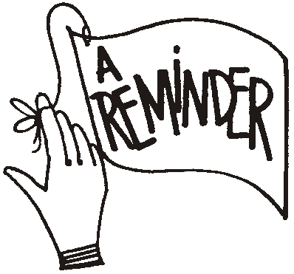
Social Studies- Urban communities
Important Dates
- May 12- Ice Cream Truck sponsored by PTO
- May 16- Science Fair Field trip (for those who did projects)
- May 17- Barnhill Preserve Assembly
- May 23- Field Day for grades 3-5
- May 24- Field trip to Lincoln Caverns
- May 25- Dismissal at 9:30 (HAPPY SUMMER!!!)

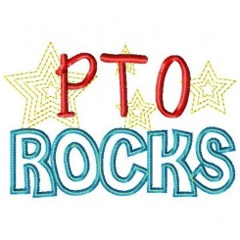
PTO has again purchased T-shirts for all of the elementary students. Your child will be given their shirt on May 19th. Please have your child wear their shirt to both Track and Field Day (May 23) and on our class trip to Lincoln Caverns (May 24).

From both 3rd grade teachers, thank you parents for all of your support and classroom donations that you have given this year!!

